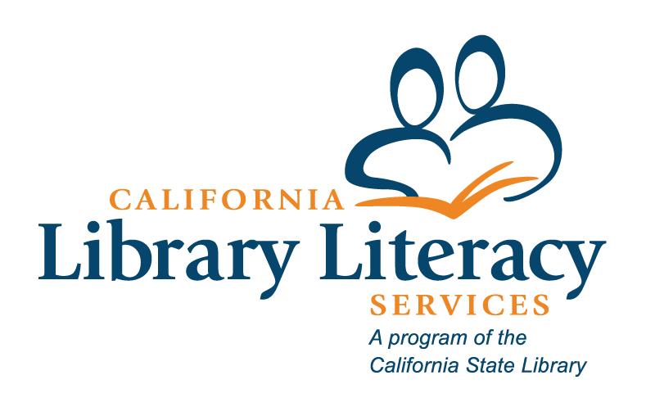

California Library Literacy Services

2024-2025 Continuing Libraries Application Form Blank Template
  - Grant Period: July 1, 2024 – June 30, 2025
  - Deadline: Thursday, May 30 (5:00 PM)
NOTE: This blank template is provided as a supplemental document to help draft your application responses. The 2024-2025 CLLS Continuing Libraries’ Application is due on Counting Opinions. Additional support can be found on the CLLS Manage Your Current Grant page.

Section 1. Applicant Information

Library Information
Question | Response
- Full legal name of library jurisdiction
- Street
- City
- Zip

1.2 Literacy Program Coordinator’s Contact Information
Question | Response
a. Name
b. Email
c. Phone
d. New coordinator since January 2024?
e. Check here if your program has an additional literacy contact person working with the program.

1.3 Library Director’s Contact Information
Question | Response
a. Library Director’s Name
b. Library Director’s Email
c. Library Director’s Phone
d. New director since January 2024?
e. For library directors: Have you read and do you agree to the CLLS program essentials? Yes/No

1.4 Authorized Representative Information
Question | Response
a. Authorized Representative’s Name
b. Authorized Representative’s Email
c. Is this individual the correct signatory on any claim forms?
If “no,” please indicate the correct individual’s name and email address.
d. Is this individual the correct signatory on any certifications?
If “no,” please indicate the correct individual’s name and email address.
e. Is this individual the correct signatory on any reports?
If “no,” please indicate the correct individual’s name and email address.

Section 2. Program Information

2.1 Basic or institutional information
Question | Response
- Program name
- What year did the program start?
- Year left/returned to the program.
- How is the program provided?
  - In-house by the library
  - Contract with another library (please provide the library’s name and the director’s contact information)
  - Contract with another agency (please provide the agency’s name and the director’s contact information)
  - Other, please specify (please provide the organization’s name and the director’s contact information)
- Number of main and branch libraries where adult library literacy services will be provided.
- Number of community locations where adult library literacy
services will be provided.
- Total number of locations.
- Number of main and branch libraries within the library jurisdiction.
- Percentage of total library outlets where adult literacy services will be provided.

2.2 Participation in Regional Networks
Question | Response
- Regional network name
- Will you or a representative from your library actively participate in your regional literacy network during the reporting period?
If “No” was selected for question 2.2.b., please explain why you or a representative were unable to participate in your regional literacy network.
- Will you or a representative from your library attend any CLLS statewide virtual network meeting or training during the reporting period?
If “No” was selected for question 2.2.c., please explain why you or a representative were unable to attend a CLLS statewide virtual network meeting or training.
- Will you or a representative from your library participate in your local Adult Education Consortium during the reporting period?
If “No” was selected for question 2.2.d., please explain why you or a representative were unable to participate in your Adult Education Consortium.

Section 3. Financial Report: Adult Literacy Services, Family Literacy Services, and English as a Second Language Services

3.1 Program Budget
Budget Categories | ALS - CLLS | ALS -  Local | FLS - CLLS | FLS -  Local | ESL –  CLLS | ESL –  Local | Total CLLS  Funds | Total Local Funds | Grand Totals | Narrative of expenses (required)
Salaries, Wages, & Benefits
Consultant Fees
Travel
Supplies/Materials
Equipment ($5,000+)
Services
Subtotal
Indirect
Totals

Section 4. Staff Commitment: Adult Literacy Services, Family Literacy Services, and English as a Second Language Services

4.1 Library Personnel
Program | FTE | Narrative (required)
Total ALS FTE
Total FLS FTE
Total ESL FTE
Total FTE – library personnel

Section 5. Description of Programs and Activities

5.1 Adult Literacy Services
Question | Response
- Adult Literacy Services
- Please describe your planned programming that explains what you will do, how you will do it, for whom you will do it, and the anticipated benefits. (Max. 150 words.)
- Please describe your outreach plans for recruiting learners and tutors to your program. (Max. 150 words.)
- Please describe how your program will engage learners in program planning and how you will discover learners’ aspirations. (Max. 150 words.)
- Anticipated number of adult learners to be served this year.

5.2 Family Literacy Services
Question | Response
- Family Literacy Services
- Family Literacy Services Continuing
- Please describe your planned programming for enrolled adult learners and their families that explains what you will do, how you will do it, for whom you will do it, and the anticipated benefits. Please include any relevant mobile literacy services that are connected to your CLLS family literacy services. NOTE: We will no longer be explicitly requesting MLLS information on this application or the final report. General library mobile services should be reported on the Public Library Survey, and CLLS-specific services using vehicles should be reported under the correct service area (adult literacy, family literacy, or ESL). (150 words.)
- Anticipated number of enrolled adult learners to be served this year with their families.
- Please describe your outreach plans and programming plans for CLLS eligible-but-not-yet-enrolled adults (with families) that explains what you will do, how you will do it, for whom you will do it, and the anticipated benefits. Please include any relevant mobile literacy services that are connected to your CLLS Family Literacy Services. NOTE: We will no longer be explicitly requesting MLLS information on this application or the final report. General library mobile services should be reported on the Public Library Survey, and CLLS-specific services using vehicles should be reported under the correct service area (adult literacy, family literacy, or ESL). (150 words.)
- Please describe how your program will engage learners in planning for your family literacy services and how you will discover learners’ aspirations for their families. (150 words.)

5.3 English as a Second Language Services
Question | Response
- English as a Second Language Services
- English as a Second Language Services Continuing
- Please describe your planned program that explains what you will do, how you will do it, for whom you will do it, and the anticipated benefits. (150 words.)
- Please describe your outreach plans for recruiting learners and tutors to your program. (150 words.)
- Please describe how your program will engage learners in program planning and how you will discover learners’ aspirations. (150 words.)
- Anticipated number of English as a Second Language learners to be served this year.

Section 6: Community Partners
Question | Response
- Community Partner | - Community Partner Description (Max. 150 words for each description.)

Section 7: Is there anything else you would like to tell us?
Question | Response
Is there anything you would like to tell us?

