Central Valley Adventure Guide

Overview
Welcome to Choose Your Adventure, where we’ve taken materials from our collections and turned them into an interactive experience loosely inspired by tabletop role-playing games like Dungeons and Dragons. All you need to play is a 20-sided die, your imagination, and a little bit of history!
This one-encounter adventure focuses on the historic conflict between California wheat growers and questionable land acquisition practices of the Railroad and the Big Four in the 1880s.
Feel free to use/add/modify this adventure to fit your own programming or educational needs! To run this activity, you may want to print out this document (or your modified version) to have it for reference. You do not need to memorize every bit in order to run the game — it’s okay to read from this guide.
Please let us know if you have any questions and keep us informed on how this programming goes for you by emailing the activity creator: Dvorah Lewis, Reference and Outreach Librarian at the California History Section, cslcal@library.ca.gov.
May your participants have an engaging and interactive experience!

A Note on Topic Choice
The Central Valley Adventure involves fantasy gameplay to avoid trivializing the often-devastating impact of the railroad on communities. However, the wrap-up portion of any adventure is a suitable space to bring up the real historic consequences of the railroad in California.
Choosing appropriate topics for your own adventures is the key to success. Keep in mind that working with history is messy. Game activities may appear to make light of real trauma, so it is important to carefully consider proposed topics in a wider historical context.

Rules to Play
The following rules help to establish safety in the group. Normally in a tabletop role-playing game (TTRPG), there is a session before play begins, known as a session 0, that goes over expectations and what players want or don’t want in the game. These rules should be posted and reviewed with players before proceeding:
- Keep it rated-PG — Avoid anything you wouldn’t see in a children’s movie.
- Find solutions that are non-violent, if possible — This rule is especially needed if you have children playing. If it’s a group of adults, make sure everyone provides consent for what they want in their game.
- Be kind to the other players and yourself — Improv is not easy and being vulnerable in that way can be intimidating for some people.
- Be curious and open to learn — Curiosity really helps with channeling creativity and allows for unconventional thinking during gameplay.
- Have fun! — The point is to have fun and learn a thing or two. By following the previous four rules, players will be more likely to do that with this activity!

Game Mechanics
The main game pieces to run this activity are 20-sided dice and 6-sided dice. After the Game Master (GM) sets the scene and the players tell the GM what they want to do, everyone rolls to determine the outcome.
- GM rolls their 20-sided die (d20) first to determine the number the players must beat with their subsequent rolls.
  - If the result is a 1, the GM gets to reroll. Keeping the result would mean players don’t have to roll at all to beat the GM’s number.
  - To keep the game fun and challenging, it was decided that the GM would have this special reroll ability. Players do not get to reroll 1s.
- Players roll their d20s
  - If they are using their chosen tool (see “Steps in Play”), then they roll a 6-sided die (d6) in addition to their d20 and add the numbers together. Even if players roll 1s, using their tool gives them a chance to beat the GM’s roll, especially if it’s a low one! This also gives other players an opportunity to assist.
  - If a player chooses to assist another instead of taking their own action, then the assisted player can roll twice and choose the higher number (known as rolling with advantage).
  - Please note that specific tools may have additional dice features, e.g. musical instrument allows a player to roll an 8-sided die (d8) instead of the d6 when adding it to their d20 roll.

Summary of Game Play
- Players choose adventure (if multiple are running simultaneously) and choose their tool.
- GM Sets the scene and asks players what they want to do and how.
- GM rolls to determine difficulty of the situation.
- The player rolls to see if they can beat the GM’s roll.
- GM narrates what happens based on the roll.
- Move on to next player if group is doing individual actions and repeat steps 3-5.
- GM wraps up the adventure by bringing it back to collection materials, the history, and serving as a teaching moment.

Steps in Play

Choose Your Tool
Players will have at least four tools or objects to choose from to take with them on their adventure. Each object has a card detailing its features and what players can do on their turn. The history of the object inspired the magical abilities, e.g. borax was once used as sunscreen, so the magical crystal tool has the ability to protect creatures from elements. The features and abilities were inspired by Dungeons & Dragons 5e (D&D). You may need review each tool with the players, especially if they are unfamiliar with TTRPGs, to help them decide which to choose.
Below are six examples used in the California History Section’s Choose Your Adventure programming: gold pan, bear figurine, magic crystal, musical instrument, lasso/rope, and a vial of hot spring water. You’ll want to have these each printed out so players can refer to it as they participate in the activity. There may be limits depending on the tool, so players can practice resource management (something very familiar to experienced TTRPG players). Please note: players are not limited to the special abilities on the card. They can do whatever they want with their tools within reason. The cards provided are meant to help people who are having trouble deciding what to do.
If you want to create your own tools, think of local history and what can be turned into magical objects that can be used in your adventures. For example, Napa might want to incorporate something with wine and perhaps the tool mirrors an Alchemy Jug (D&D 5e) or can be a vial of wine that has common myths informing the abilities. Or for Los Angeles, they might do something with smog: a magical bomb that can do things similar to a Fog Cloud spell or Poisonous Gas (D&D 5e).
Feel free to reach out if you need help brainstorming ideas and special features!
- Gold Pan
  - Find Gold: Roll a 10-sided die once and find gold wherever you are if you roll a 10. (A d20 can be used in its place if there is no d10 and they find gold on a 10 or a 20.)
  - Multifunctional Item: use as a shield, a shovel, a food dish, etc.
  - Danger Sense: If it’s in your hand, it will forewarn you of danger by dipping or tugging downward similar to a gold dowsing rod.
- Bear Figurine
  - Throw the figurine in front of you and it becomes a living bear. You may even have a special command word you say as you throw it.
  - The bear is friendly to you and your allies.
  - It understands and obeys commands.
  - The bear returns to a figurine after 3 hours.
- Magic Crystal (aka Borax)
  - Sensory Effects: You create harmless, minor effects, e.g. shower of sparks, a puff of wind, faint musical notes etc.
  - Create Water: You can create up to 10 gallons of clean water or cause it to fall from the sky like rain.
  - Disguise Self: For 1 hour, you can make yourself look different. This includes clothing and belongings you carry.
  - Protection from the Elements: A creature under this spell is protected from one element of your choosing (Earth, Water, Fire, Air).
  - Players have enough magic to do two spells for the entire adventure (so if multi-encounter, they must choose wisely).
- Musical Instrument
  - Bardic Inspiration: Inspire others with your music (including your party members). Roll a d8 instead of the d6 you get for using your tool and add it to your d20 outcome roll.
  - Charm Creature: Using your musical notes, persuade a hostile creature to see you as friendly.
  - Enthrall: Weave distracting notes and grab attention of all who hear your music. The higher the roll, the longer the distraction will last!
- Lasso/Rope
  - Multifunctional Item: You can use it for restraining, climbing, hunting, carrying, etc.
  - Lasso of Truth: If you tie someone up with it, they cannot tell a lie and must tell the truth.
  - Magical Trap: On a flat surface, create a circle with the rope. Say a magic command word and it will disappear, turning into a trap.
- Vial of Hot Spring Water
  - Cure Wounds: The wounds on a creature you touch are immediately healed.
  - Tidal Wave: You conjure up a wave that can knock creatures off their feet.
  - Calm Emotions: You suppress strong emotions in a group of creatures. You can also make a hostile creature indifferent to its target.
  - Shape Water: You can manipulate a section of water by changing the flow, animating into shapes, changing the opacity or color, or freezing.
  - Players have enough magic to do two spells for the entire adventure (so if multi-encounter, they must choose wisely).

Setting the Scene
The Game Master (GM), a.k.a. the person running this activity, first describes to the players where they are in the scene. One tip is to engage three of the five senses. Here’s an example of setting the scene for this adventure:
It’s the 1880s, and you’re a wheat rancher in San Joaquin Valley. There’s a monster that is taking over much of California, connecting cities with its tentacles and accumulating too much wealth and power. This monster’s control is threatening your profession, harming businesses and corrupting the government. Now one of its tentacles has reached your town. It’s a sunny day but the encroaching tentacle is so big that it blocks out the sun and makes it hard for the townspeople to go about their business. You can hear the jingle jangle of treasures from the monster’s hoard, stuck to the tentacles’ suction cups. There’s an overall feeling of worry and fear. You hear a stranger you don’t recognize telling townsfolk that “it’ll be okay, the tentacle means well,” but this does not assuage those who are becoming increasingly agitated and angry by the monster’s presence.

Players Decide What to Do
  - GM asks players “What do you do to stop the tentacle from taking over your town and adding your possessions to its treasure hoard?” Or if the players choose to go along with the tentacle, then ask instead “What do you do to convince others that everything will be ok?”
  - Collaborating will give them better odds for success, but they are also free to split up and try different things with their actions. Follow the Game Mechanics in the previous section for outcome rolls.
  - The GM can also suggest the following options if players need inspiration:
    - Organize the community. You fight the giant octopus tentacle; or
    - Rob the octopus and give back to the people.
    - Enlist a government official to be your champion.
  - Players decide what order to go in.

Roll for the Outcome
The GM rolls for all to see what number they need to beat. If players are acting separately, then GM may roll for each action, giving each player a different number to beat. Then the player whose turn it is rolls to see how effective they are at doing whatever it is they decided. If the player’s number beats the GM’s number, then the player is successful in that action. If there’s more than one player in the party, then successful rolls must equal more than half the group’s party size (round up for odd numbers) for it to be a successful encounter. For example, two out of three players roll higher than the GM, that equals a successful encounter.
  - Examples of successful encounter outcomes (this will vary based on what the players say they do for their turns and how good they roll):
    - You fight back the tentacle, and the monster decides you’re too much trouble for it to deal with, so leaves to find another town to settle in.
      - Advanced Game Mechanic: You can do a luck roll to see what becomes of their town. An unintended consequence could be the town eventually turns into a ghost town. Resources are cut off and now people have to move. Or this town is successful on its own and doesn’t need to be near or on the railroad’s route to survive. A luck roll can be a d6 (odds/evens) or just use an old-fashioned coin flip. Using dice will be easier.
    - You steal from the tentacle and are able to create a town fund with the money.
    - Your champion is able to fight for lower fees so that you may keep your home, but the tentacle still settles in your town.
  - Examples of unsuccessful encounter outcomes (again, this will vary based on what the players say they do for their turns and how badly they roll):
    - You are unable to defeat the tentacle and must stay in the town knowing this monster will take some of your wealth or you must decide to leave and settle elsewhere;
    - You are caught stealing and sent to prison;
    - Your champion betrays you at the last second, accepting a bribe from the monster;
    - The tentacle takes over your land, kicking you out of your home and giving it to someone more loyal to them.

Wrap-up the Adventure
At the end, the GM wraps up the adventure, bringing it back to the materials on the table and providing more historical context. The following may need to be shortened depending on how much time you have with participants; make sure to point to the materials on the table as you talk about the history. Here’s an example of what could be said with materials pointed to in brackets (see Pull List for complete list of materials):
The octopus represented the railroad and the Big Four, the four men who financially backed the railroad in California: Leland Stanford, Collis P. Huntington, Mark Hopkins, and Charles Crocker. Their corrupt business practices led them to being depicted in journals and stories as this monster that had a stranglehold over the state [point to The Wasp octopus illustration and Frank Norris’ The Octopus].
The railroad used pay-to-play schemes where they demanded generous subsidies from towns before they built in an area; and they also used corrupt land acquisition and sale practices—which was the inspiration for this scenario that you just played. The government granted lots of land to the railroad. The railroad, in turn, promised would-be white settlers interested in leasing this land good purchase rates when the tracks were completed [pamphlet by Southern Pacific]. However, when the railroad did complete the line and sell the land, it often did so at the “developed” price of $20/acre rather than the good “undeveloped” price advertised at $2.50/acre. The price changes left several settler families homeless and in some cases, like with the Mussel Slough Tragedy, they led to deadly conflict as settlers fought to retain the land [pamphlet spreading the truth about Mussel Slough Tragedy].
The overall abuses led to a myriad of public responses including lawsuits, legislation at the state and federal level, and creative local solutions. There are even examples of short-lived anti-railroad political parties who created musical sheets like this one [Anti-Monopoly musical sheet] as well as an example of a community coming together to fund their own rail line breaking the monopoly of the Southern Pacific: the San Francisco and San Joaquin Valley Railway, which ran between Stockton and Bakersfield [History of San Francisco and San Joaquin Valley Railway].
The state and federal government made many attempts to curb the railroad’s power during the late 19th and earlier 20th century, including establishing the board of transportation commissioners and establishing a universal recall to weed out politicians corrupted by the railroads. They also passed a rate regulation act.
Reality is more nuanced and not as clear cut as the adventure portrayed. There are examples of towns whose prosperity relied on the railroad passing through them so that, if the railroad changed routes, for example, the people would move with the railroad, turning once prosperous places into ghost towns.

Additional Resources
Also in the wrap-up, point to a flyer with a QR codes directing participants to learn more on subjects that weren’t covered in the adventure, e.g. a virtual talk on the railroad and farm communities; articles on those impacted by the railroad; article on racism and satire in The Wasp which while anti-railroad was also anti-Chinese; an in-depth history of agriculture in California; and a blog post offering an example of a ghost railway town.
A list of links can be provided as a or via email upon request. See full list in next section.

List of Links
- “California Railroads and Farm Communities” with Maria McVarish. Virtual talk focusing on Capay Valley, CSPAN, https://www.c-span.org/video/?507400-1/california-railroads-farm-communities
- “Photo Essay: The Ghost Railway of Eastern California” about Laws, CA, a town which once served as a train depot, Avoiding Regret blog, https://www.avoidingregret.com/2017/05/photo-essay-ghost-railway-of-eastern.html
- “A Historical Context and Methodology for Evaluating Agricultural Properties in California” for an in-depth look at the history of agriculture in California, California Department of Transportation, https://dot.ca.gov/-/media/dot-media/programs/environmental-analysis/documents/ser/historical-context-agricultural-properties-ca-a11y.pdf
- People impacted by the railroad, National Park Service, https://www.nps.gov/gosp/learn/historyculture/people.htm
- Guide to the Frank Norris collection – author of The Octopus, https://oac.cdlib.org/findaid/ark:/13030/tf6g500585/
- “Geography of Chinese Workers Building the Transcontinental Railroad” a virtual reconstruction of historic sites, Stanford University, https://web.stanford.edu/group/chineserailroad/cgi-bin/website/virtual/
- “The Transcontinental Railroad, African Americans and the California Dream,” California Historical Society, https://californiahistoricalsociety.org/blog/the-transcontinental-railroad-african-americans-and-the-california-dream/
- “WASP: Racism and Satire in the 19th Century,” FoundSF, https://www.foundsf.org/index.php?title=WASP:_Racism_and_Satire_in_the_19th_Century
- “California’s earliest Black settlers bought land only for it to be stolen. Their descendants want it back,” NBC News Reparations Report, https://www.nbcnews.com/news/nbcblk/black-californians-stolen-land-reparations-rcna84970
- Empire’s Tracks: Indigenous Nations, Chinese Workers, and the Transcontinental Railroad by Manu Karuka, book circulating in the California History Reading Room, https://csl.primo.exlibrisgroup.com/permalink/01CSL_INST/kjolsn/alma9916633748405115

Pull List

Choose Your Tool

Bear Figurine
“Spaulding’s Big Bear Woods” Shapebook
Located in Textual Files: Shape books.
No catalog record.
Shape books were created from die-cutting a process developed during the Industrial Revolution. Advertisers quickly realized that the unique shapes captured viewers’ attention.
Bear figurine from the Curiosities Cabinet in our Rare Materials Reading Room is also on display with this shape book.

Vial of Hot Spring Water
Paraiso Hot Springs, Monterey Co., California pamphlet
Located in 2nd Floor Stacks
https://csl.primo.exlibrisgroup.com/permalink/01CSL_INST/kjolsn/alma990003940650205115

San Luis Hot Sulphur Springs, San Luis Obispo, California pamphlet
Located in 2nd floor Stacks.
https://csl.primo.exlibrisgroup.com/permalink/01CSL_INST/kjolsn/alma990015141470205115
A brief story about Witter Medical Springs and Witter Springs Hotel, situated in Lake County pamphlet
Located in 2nd floor Stacks.
https://csl.primo.exlibrisgroup.com/permalink/01CSL_INST/kjolsn/alma990001624510205115.

Pamphlets advertising three different springs found in California. Indigenous tribes long considered spring water and hot springs to be sacred and spiritual before settlers commercialized the springs and dispossessed tribes of their land. Spring water is said to cure all sorts of illnesses and ailments, from easing physical stress and calming the mind to soothing aches and arthritis as well as skin conditions. Spring water has added to the mythic quality of California as a place of paradise and healing.
Also on display with the pamphlets is a vial from a personal collection.

Gold pan
Panning gold near Columbia, Stellman collection
Located in Photo Collection- Mines: Mining: Gold: Methods
No catalog record.
One of the first techniques for mining gold miners relied on was panning which was the process of swirling and agitating water from a stream in a shallow pan until heavier, gold-bearing materials fell to the bottom while water and lighter sand fell out over the rim. The pan in the photograph contains $30 worth of nuggets washed from creek-sand.
Bronze statue of gold miner from Reading Room Reference Desk is also display alongside this photo.

Magic Crystal (aka Borax)
Borax : the Magic Crystal. New York: Pacific Coast Borax Company, pamphlet
Located in 2nd Floor Stacks.
https://csl.primo.exlibrisgroup.com/permalink/01CSL_INST/kjolsn/alma990005810840205115
More commonly used today as a laundry booster or for cleaning sinks, back in the 19th and even early 20th century, Borax was advertised as a magic crystal that could solve all your problems, especially as they relate to cleanliness and hygiene. The 20-mule team that was used to transport this mineral from Death Valley to consumers only added to its mystique. This pamphlet from 1919 was likely created as part of this advertising campaign. The reader can find many uses listed inside that we wouldn’t necessarily employ today, such as using as an antiseptic, in cosmetics, as a sunscreen, to soften your hands, or to even remove freckles!
Selenite crystal and velvet bag from personal collection on display alongside pamphlet.

Lasso/Rope
“The Cow Puncher” - Remington, Frederic, and Owen Wister. Done in the Open; Drawings. New York: R. H. Russell, 1902.
Located in Basement Rare General Collection.
https://csl.primo.exlibrisgroup.com/permalink/01CSL_INST/kjolsn/alma990000678390205115

Traditional tool especially for Spanish and Mexican cowboys, this loop of rope was designed as a restraint to be thrown around a target and tightened when pulled. While not specific to California, one can guess that the lasso increased in popularity once cattle were brought to the region in the late 1700s. Today, lassos are still used on ranches and even in competitive events like rodeos.
This drawing is done by Frederic Remington, who is best known for his art depicting cowboys, soldiers, and the Indigenous peoples of the West. He created illustrations like this one for widely read magazines, such as Harper’s Weekly, shaping the world’s perception of the American West.

Musical Instrument
[C.W.J. Johnson with His One-Man Band Invention]. N.p., 1890.
Located in Photo Collection – Portraits: Johnson, Charles Wallace Jacob.
https://csl.primo.exlibrisgroup.com/permalink/01CSL_INST/kjolsn/alma990013868510205115
A seated portrait of C. W. J. Johnson with his invention (a tuba-like instrument) and a guitar. Musical instrument is another universal tool not specific to California; however, folk guitar was brought over by the state’s Mexican population, making music that others saw as distinctively Californian and different from Mexican and Spanish music. This type of folk music would dwindle as more immigrants came to the state. California is known for its history of innovation in music. One such innovation was the electric guitar, born in Los Angeles.
Pied Piper. The Pied Piper, 1916. N.p., 1916.
Located in Photo Collection – San Diego Co.: San Diego: Panama-California International Exposition, 1916.
https://csl.primo.exlibrisgroup.com/permalink/01CSL_INST/kjolsn/alma990013858910205115
A full-length side portrait of a man wearing a cape, pointed felt hat with feather, court jester-striped sleeves and trunks, and elven shoes, holding reed flute pipe. From the Panama-California International Exposition which occurred in San Diego in celebration of the Panama Canal opening and to tout San Diego as the first port of call for ships traveling north from the canal.

Central Valley Adventure Materials

The Wasp (San Francisco, Calif. : 1880). San Francisco, Calif: Wasp Pub. Co., 1880.
Located in 2nd Floor Stacks.
https://csl.primo.exlibrisgroup.com/permalink/01CSL_INST/kjolsn/alma990009560630205115
The Wasp was a weekly satirical magazine with mass printings of color lithographs. "The Curse of California" was an illustration that appeared in The Wasp on August 19, 1882, and is the likely origin of the depiction of the Southern Pacific Railroad monopoly as an octopus. While The Wasp may have been progressive when it came to being anti-railroad, they did publish many racist articles and illustrations that were anti-Chinese.

Norris, Frank. Octopus : a Story of California. Golden Gate ed. New York: Doubleday, Page & Co., 1903.

Located in Basement Fiction.
https://csl.primo.exlibrisgroup.com/permalink/01CSL_INST/kjolsn/alma990003506910205115
Originally published in 1901, this book was the first part of an uncompleted trilogy describing the wheat industry in California and the conflict between farmers and the railway in San Joaquin Valley. It was inspired by the Mussel Slough Tragedy (1880), a deadly conflict between farmers and railroad agents over the ownership of ranches. The farmers leased the land with intentions of buying at a fair market rate. Ten years later, the railroad put the land up for sale for a much higher rate than they promised.

“Map of Yosemite Valley Railroad.” place of publication not identified: [publisher not identified] 1907.
Located in Basement Small Maps. https://csl.primo.exlibrisgroup.com/permalink/01CSL_INST/kjolsn/alma9916662720405115
Map from 1907 showing the railroad lines of Central Valley. (If more space is needed on table then I don’t include the map).

California Self-Supporting Homes! : How to Get Them! : This Pamphlet on Small-Scale Farming and Fruit Culture in California Has Been Prepared for General Use. San Francisco: The Company, 1890.
Located in 2nd Floor Stacks.
https://csl.primo.exlibrisgroup.com/permalink/01CSL_INST/kjolsn/alma990010326710205115
A pamphlet prepared by the Southern Pacific to encourage people to move to California, specifically San Joaquin Valley, to establish a small farm and “self-supporting homes” and increase development along their lines. It details what the settler would expect if moving to the area and answers questions from what the weather is like to what there is to do for work. Likely the people who took the Railroad up on this offer may have done something other than farming as their occupation. This pamphlet seeks to dissuade them of any fears. It even includes profit projections to further entice people to make the move. Southern Pacific often published brochures like this one.

All about Kern County, California. San Francisco: Press of H.S. Crocker Co., 1892.
Located in 2nd Floor Stacks.
https://csl.primo.exlibrisgroup.com/permalink/01CSL_INST/kjolsn/alma990012525100205115
Another example of a pamphlet that was created to encourage people to settle in California, specifically in Kern County. The pamphlet has a list of answers to common questions potential settlers may have. Examples include explaining topography, climate, cost of living, and even how close the tracts are to the railroad. The Kern County Land Company had hundreds of thousands of acres of land available for sale in the hopes to cultivate more fruit farming.

The Struggle of the Mussel Slough Settlers for Their Homes! An Appeal to the People; History of the Land Troubles in Tulare and Fresno Counties. The Grasping Greed of the Railroad Monopoly. Visalia;: Delta printing establishment, 1880.
Located in 2nd Floor Stacks.
https://csl.primo.exlibrisgroup.com/permalink/01CSL_INST/kjolsn/alma990003147940205115
A pamphlet prepared by the Settler’s Grand League in opposition to Southern Pacific Railroad. The goal of this publication was to spread the League’s truth about the tragedy at Mussel Slough (a deadly dispute over land titles between settlers and the railroad) and why the ranchers believe the land rightfully belonged to them. It includes transcriptions of correspondence as evidence, especially for the fact that the land would be sold at $2.50 – no more than $10 per acre. The settlers also claimed that they came to this land when they had nowhere else to go, and they made the dry soil farmable by creating irrigation ditches. The railroad increased the costs because of these improvements that were made, charging $20 acre (double the max they originally promised). Unfortunately, the League lost and 5 people (including the leader of the League) were later found guilty and imprisoned for willfully interfering with a marshal in performance of his duties, which led to the Mussel Slough Tragedy. These five were seen as heroes in California and upon their release from prison were greeted by a crowd of 3,000. During this time, the incident received nationwide attention but, as time went on, became lost to history and not as remembered as it once was.

Harrison, R. J. “Anti-Monopoly War Song.” 1882: n. pag. Musical sheet
Located in Textual Files: Musical Sheets.
https://csl.primo.exlibrisgroup.com/permalink/01CSL_INST/kjolsn/alma990013800200205115
“Anti-Monopoly War Song composed for The Anti-Monopoly Party of California dedicated to R.J. Harrison” printed in 1882. The Anti-Monopoly Party was a short-lived political party founded in 1874 and dissolving in 1886, merging into the Populist party. One opposition of the party was the use of tariffs and the granting of public land to railroads and other corporations. This musical sheet meant to be accompanied by piano is about the opposition to the railroad monopoly and calling folks to “Hurl the Monster from your way” and join their cause. Other copies of this sheet include a political ad saying “Vote for W. W. Foote, Regular Nominee, Railroad Commissioner Third District, Anti-Monopoly Ticket. A Vote for Foote is a Vote for Liberty Against Railroad Tyranny.” He was in fact elected and became a Railroad Commissioner in 1883-1887 and fought for rate reductions during his tenure but to no avail.
Because this musical sheet is so fragile, we display a surrogate of it during the adventure.

Collection of Postcards
“Front Street, Looking North, Lathrop Cal.”
Located in Postcard Collection - San Joaquin: General View.
“1696 - Merced St, Main Business Section, Fowler, California.”
Located in Postcard Collection - Fresno Co: General.
“10974 A Twenty-Four Horse Power Harvester. San Joaquin Valley, Calif.”
Located in Postcard Collection - San Joaquin Co: Agriculture.
“10994 Five Team Train of Wagons, San Joaquin Valley, Calif.”
Located in Postcard Collection - San Joaquin Co.: General View
No catalog records.
Postcards show views of harvesting wheat and a general view of what towns in San Joaquin Valley may have looked like in the 1880s-1900s. The Valley developed a reputation of producing high-quality wheat. The grain was easy to grow in a land with no irrigation and prone to drought. Once trains were developed, farmers could transport their crops to Stockton in the matter of days versus the weeks it took via wagons and barges. The image of the harvester likely dates after 1883 when it was invented by the Holt brothers of Stockton.

The Valley road : a history of the Traffic Association of California : the League of Progress : the North American Navigation Company : the Merchants' Shipping Association : and the San Francisco and San Joaquin Valley Railway : with portraits of representative men that advocate California's progress and industrial supremacy. San Francisco: Wheeler, 1896.
Located in 2nd Floor Stacks.
https://csl.primo.exlibrisgroup.com/permalink/01CSL_INST/kjolsn/alma9916675421405115
Frustration at rate prices as well as location of the depot itself may have led to discussion of a new line, at least for those living in Bakersfield who endured a strained relationship with Southern Pacific when the latter chose to place their depot 3 miles east of Bakersfield. In the late 1890s, the San Francisco and San Joaquin Valley Railway Company was born: a rail line that ran between Stockton and Bakersfield, it was created to compete with Southern Pacific and break their monopoly. One big financial backer was Claus Spreckels, known for his sugar manufacturing company. Smaller investors from all over the state contributed giving it the nickname the “People’s Railroad.” This railway offered lower shipping rates and caused Southern Pacific to do the same in order to compete with the new line. Not long after, the Valley Railway was then purchased by the Atchison, Topeka, and Santa Fe Railroad to become part of their division and the line is still around today.

Example of Table Layout
Embedded photographs below show an example of how these materials might be laid out on the table for the Central Valley activity. Please note some things may have moved when deploying the activity, but the table generally looks like this. For example, the dice tray is set closer to participants and not in the middle of the table as it is shown here. Not pictured: a sign specifically saying which section is “Choose Your Tool” and which is the “Central Valley Adventure;” rules for gameplay; a low-resolution surrogate of the musical sheet; and any other decorations you may have.
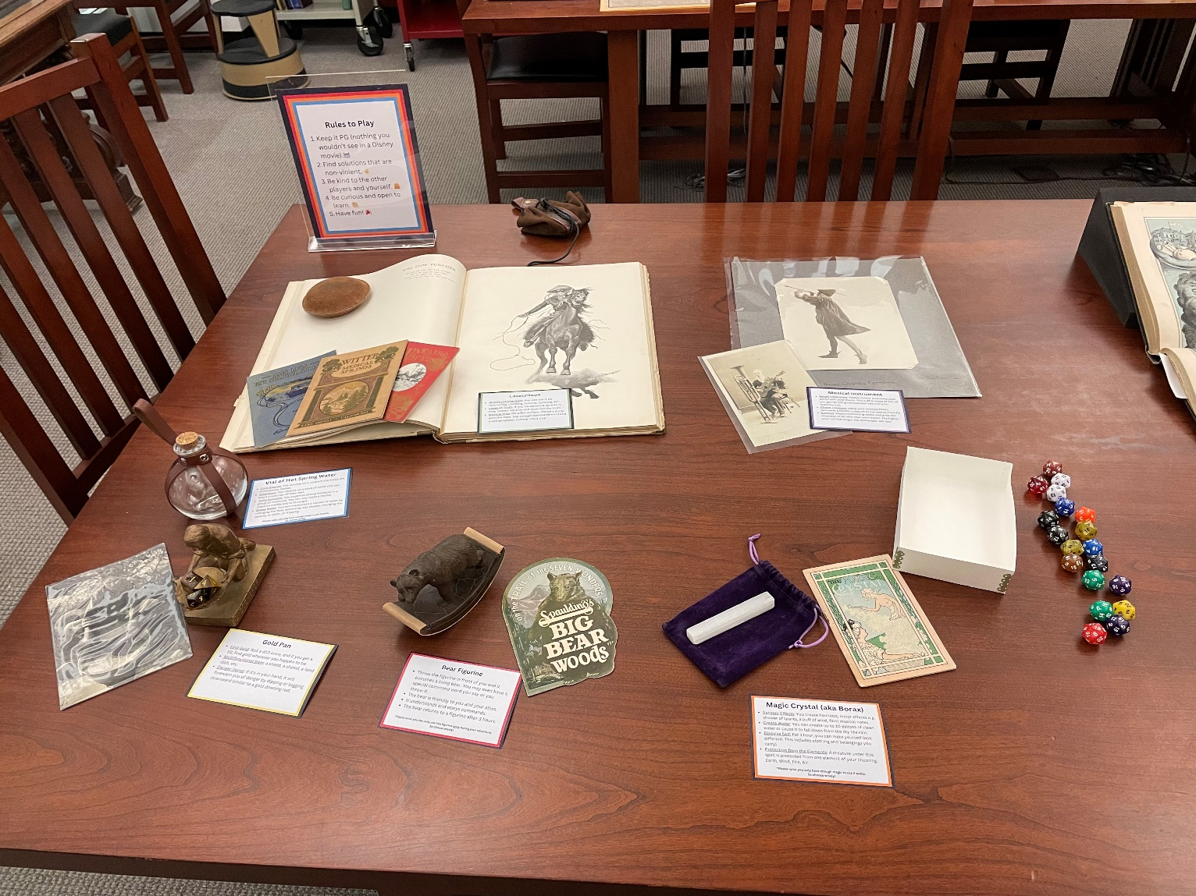
Choose Your Tool section of the table. The left side of the table where participants will start.
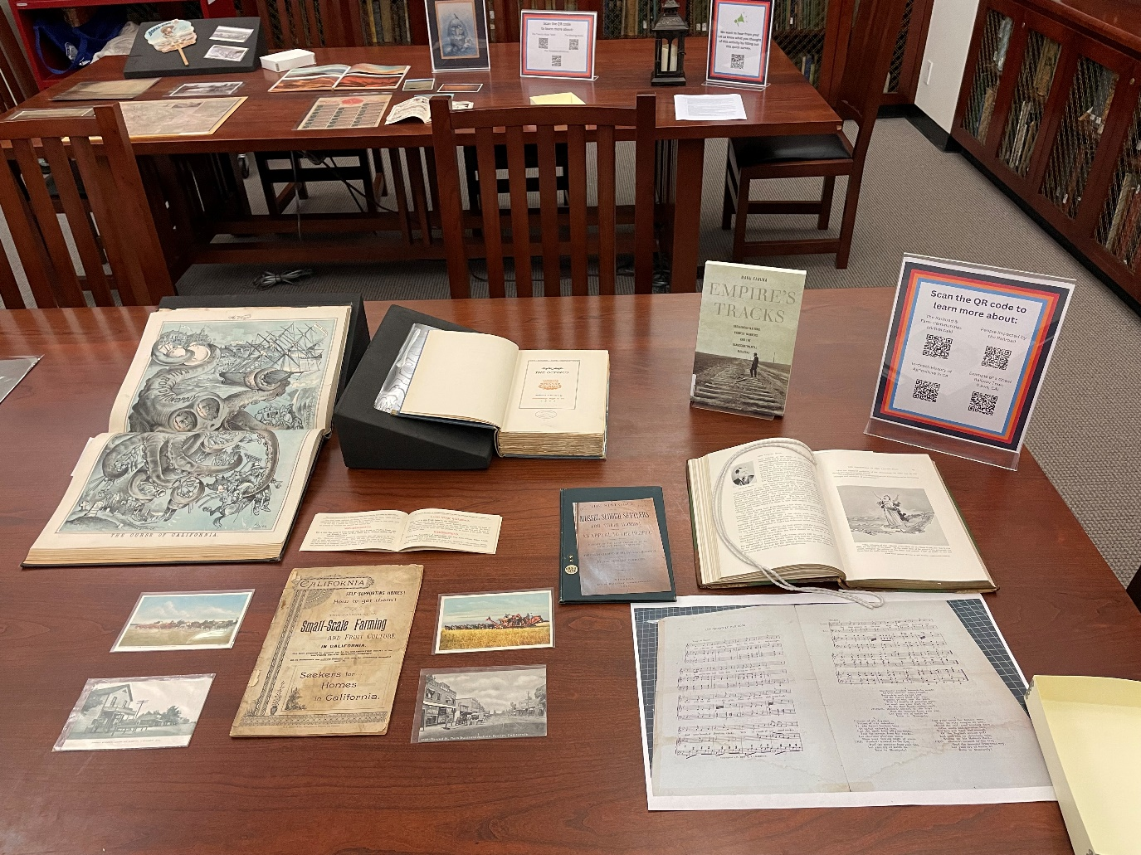
Adventure section of the table is to the right of the tools section. We see the Central Valley Adventure as an example.

