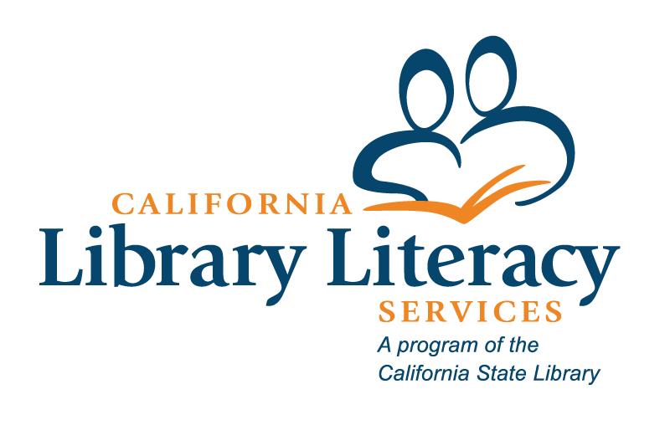

California Library Literacy Services

2024-2025 Mid-Year Report and

2025-2026 Pre-Application Blank Template

Grant Period: July 1, 2024 – June 30, 2025  
Report Period: July 1 – December 31, 2024

Deadline: Monday, February 3, 2025, at 5:00 pm

# Section 1: Jurisdiction Information

## 1.1 Library Information

| **Question** | **Response** |
| --- | --- |
| 1. Full legal name of library jurisdiction |  |
| 1. Street |  |
| 1. City |  |
| 1. Zip |  |

## 1.2 Literacy Program Coordinator’s Contact Information

| **Question** | **Response** |
| --- | --- |
| 1. Name |  |
| 1. Email |  |
| 1. Phone |  |
| 1. Is this a new coordinator since September 2024? |  |

## 1.3 Library Director’s Contact Information

| **Question** | **Response** |
| --- | --- |
| 1. Library Director’s Name |  |
| 1. Library Director’s Email |  |
| 1. Library Director’s Phone |  |
| 1. Is this a new library director since September 2024? |  |

## 1.4 Authorized Representative Information

| **Question** | **Response** |
| --- | --- |
| 1. Authorized Representative’s Name |  |
| 1. Authorized Representative’s Email |  |
| 1. Is this individual the correct signatory on any claim forms? |  |
| If “No” was selected for question 1.4.c., please indicate the correct individual’s name and email address. |  |
| 1. Is this individual the correct signatory on any certifications? |  |
| If “No” was selected for question 1.4.d., please indicate the correct individual’s name and email address. |  |
| 1. Is this individual the correct signatory on any reports? |  |
| If “No” was selected for question 1.4.e., please indicate the correct individual’s name and email address. |  |

# Section 2: Program Information

## 2.1 Basic Program Information

| **Question** | **Response** |
| --- | --- |
| 1. Program Name |  |
| 1. How is your 2024-2025 program provided?  * In-house by the library * Contract with another library (please provide the library’s name and the director’s contact information) * Contract with another agency (please provide the agency’s name and the director’s contact information) * Other, please specify (please provide the organization’s name and the director’s contact information) |  |
| b.i. Add additional contact information. |  |

# Section 3: Description of Programs and Activities

## 3.1 Adult Literacy Services

| **Question** | **Response** |
| --- | --- |
| 1. Adult Literacy Services |  |
| 1. Describe your program activities from July 1, 2024, through December 31, 2024, including: We did what, how, for whom, with what benefits (max. 150 words) |  |
| 1. Describe any challenges you are experiencing with your Adult Literacy Services program or program activities. What can the State Library do to help with these challenges? (Ex: Training, community conversations, etc.) (max. 150 words) |  |
| 1. Approximately how many adult learners did you serve between July 1, 2024 - December 31, 2024? |  |
| 1. Are you on track to spend your 2024-2025 CLLS Adult Literacy Services funds? |  |

## 3.2 Family Literacy Services

| **Questions** | **Response** |
| --- | --- |
| 1. Family Literacy Services |  |
| 1. Describe your Family Literacy Services program activities for **enrolled adult learners and their families** for the period between July 1, 2024, and December 31, 2024 by explaining what you did, how you did it, who you did it for and with what benefits. (max. 150 words) |  |
| 1. Describe any challenges you are experiencing with your Family Literacy Services program or program activities. What can the State Library do to help with these challenges? (Ex: Training, community conversations, etc.) (max. 150 words) |  |
| 1. Approximately how many enrolled adult learner families did you serve between July 1, 2024 - December 31, 2024? |  |
| 1. Are you on track to spend your 2024-2025 CLLS Family Literacy Services funds? |  |

## 3.3 ESL Services

| **Question** | **Response** |
| --- | --- |
| 1. ESL Services |  |
| 1. Describe your ESL Services program activities from July 1, 2024, through December 31, 2024, by explaining what you did, how you did it, who you did it for and with what benefits. (max. 150 words) |  |
| 1. Describe any challenges you are experiencing with your ESL Services program or program activities. What can the State Library do to help with these challenges? (Ex: Training, community conversations, etc.) (max. 150 words) |  |
| 1. Approximately how many ESL learners did you serve between July 1, 2024 - December 31, 2024? |  |
| 1. Are you on track to spend your 2024-2025 CLLS ESL Services funds? |  |

## 3.4 Comments

| **Questions** | **Response** |
| --- | --- |
| 1. Describe any program changes or challenges since you submitted your application last spring. |  |
| 1. Would you like to receive one-on-one support for the changes or challenges you identified in 3.4.a.? |  |
| 1. Is there anything else you would like to share? We welcome great stories. |  |

**Section 4. Financial Report: Adult Literacy Services, Family Literacy Services, and English as a Second Language Services**

| **Budget Categories** | **ALS- CLLS** | **FLS - CLLS** | **ESL –**  **CLLS** | **Grand Totals** | **Narrative of expenses** |
| --- | --- | --- | --- | --- | --- |
| Salaries & Benefits |  |  |  | Auto |  |
| Consultant Fees |  |  |  | Auto |  |
| Travel |  |  |  | Auto |  |
| Supplies and Materials |  |  |  | Auto |  |
| Equipment ($5,000+) |  |  |  | Auto |  |
| Services |  |  |  | Auto |  |
| Subtotal | Auto | Auto | Auto | Auto |  |
| Indirect |  |  |  | Auto |  |
| Totals | Auto | Auto | Auto | Auto |  |

**4.2 Does your library have remaining CLLS funds that need to be spent?**

| **Question** | **Response** |
| --- | --- |
| 1. Does your library have 2022-2023 CLLS funds that currently need to be spent? |  |
| If “yes” in 4.2.a., how much remaining 2022-2023 CLLS funds need to be spent? |  |
| 1. Does your library have 2023-2024 CLLS funds that currently need to be spent? |  |
| If “yes” in 4.2.b., how much remaining 2023-2024 CLLS funds need to be spent? |  |
| 1. If you answered “yes” to 4.2.a. or 4.2.b., do you have an approved spending plan on file? |  |

# Section 5: 2025-2026 Pre-Application

## 5.1 Current Program Information

| **Question** | **Response** |
| --- | --- |
| 1. Are you continuing your CLLS Adult Literacy Services program in 2025-2026? |  |
| 1. If you currently have a Family Literacy Services program funded by CLLS funds, do you plan on continuing this program in 2025-2026? |  |
| 1. Do you anticipate any significant changes to your program(s) in 2025-2026? |  |
| c.i. If you selected “yes” in 5.1.c., please explain any foreseeable changes to your program(s) in 2025-2026. (Ex. Changes in local funding, vacancies, or other significant areas) |  |
| 1. Are you interested in beginning a CLLS Family Literacy Services Program in 2025-2026? |  |

## 5.2 New CLLS Family Literacy Program

| **Question** | **Response** |
| --- | --- |
| 1. Provide a description of your planned program by explaining what you will do, how you will do it, for whom you will do it for and with what benefits. |  |
| 1. Describe your planned family literacy outreach activities. |  |
| 1. Anticipated number of adults enrolled in your CLLS Adult Literacy Services program who will receive family literacy services. |  |
| 1. Anticipated number of children of adults enrolled in your CLLS Adult Literacy Services program who will receive family literacy services. |  |
| 1. Anticipated number of other families that include an unenrolled adult who is eligible for your CLLS program who will receive family literacy services. |  |