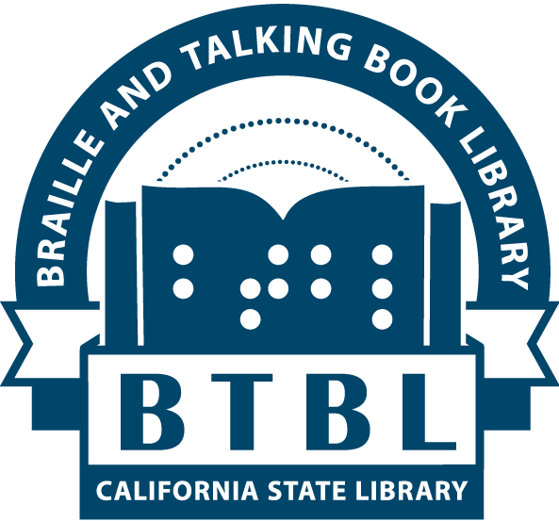 | BTBL News  Braille and Talking Book Library  California State Library, Sacramento, CA
New Series no. 19 (Spring/Summer 2018)
In This Issue:
- Director's Message
- Because Summertime Means Books and Prizes!
- Survey Results Summary
- Accessories to Fit Your Needs
- Enhanced Security for your BARD Account
- Tell Us What You Like (and Don’t Like)
- Thank Your Postal Carrier

A Message from Mike Marlin, Director

A splendid Spring greeting to you from BTBL headquarters in Sacramento, the Reading Depot with books and magazines for all.

First, thanks to all who completed our Fall Patron Survey. You can learn about the results in a separate article below. There was overwhelming support for an Assistive Technology vendor fair. Therefore, we are partnering with Sacramento’s Society for the Blind and NorthState Assistive Technology to sponsor a Resources and Technology Fair at Society’s 1238 S Street midtown Sacramento location on Saturday, November 3, 10AM to 2PM. Tune in to our Facebook page, website, BTBL Updates emails (which you can sign up for at library.ca.gov/mailing-lists), or contact us in the Fall months for further details. We hope to see many of you there.

Secondly, a best practices reminder to our avid talking book readers who borrow books on cartridges via mail. Please remember to check that the DB number and title of a book cartridge matches the container’s title and book number. We are accumulating quite a few mismatched cartridges and containers and it takes a lot of extra time to reacquaint book orphans with their containers so we can recirculate a book eagerly awaited by a fellow patron. Thanks in advance for your careful consideration to the matter.

Our digital talking book machines were introduced in late 2008 and they have held up remarkably well for a decade. Now, the National Library Service for the Blind & Physically Handicapped (NLS) has begun development on the next generation of talking book machine. Though it will be several more years before a prototype is ready, innovations such as wireless delivery are in research mode. A pilot study is currently underway to test cellular delivery to patrons. Entitled MOCA (short for Mobile Cartridge), library patrons without internet access around the country, including California, are testing the MOCA device; a hand-built device that allows a cartridge to be inserted, and through talking menus, books are downloaded from the ether via nearby cellular towers. This is one of many innovations from the NLS Washington D.C. brain trust! We’ll keep you apprised of the pilot’s success and future innovations as they arise.

I want to give a warm welcome to BTBL’s newest staff member, Audio Visual Assistant Christopher Duran who started in April. Christopher will be coordinating BTBL’s volunteer Narration Studio and ramping up production of locally recorded books to add to our Californiana Collection--California authors and subjects not covered by the national NLS talking book collection.

Finally, I had the privilege of traveling to Brussels, Belgium, in February to attend meetings for the Libraries Serving Persons with Print Disabilities committee, a group of international libraries for the blind representatives. In addition to participating in a lively discussion of print-disability library concerns, I experienced some of the well-known features of Brussels. My guide dog Vivaldi and I heard brass marching bands in the public squares every day despite the very cold -5 Celsius temperatures. One evening we went on a Belgian chocolate tasting tour, encountered a statue of the world famous native singer Jacques Brel, and of course, sampled a Belgian waffle per local recommendation with only a modicum of powdered sugar but no chocolate sauce or strawberries! And if your appetite is now primed for more literary morsels, please digest this tasty edition of BTBL News.

Because Summertime Means Books and Prizes!

Like reading books and winning prizes? Then we’ve got the summertime activity for you! BTBL is pleased to announce that we are continuing, and improving, our Summer Reading Program.

How it works:
- Read library books (any audio or braille book borrowed or downloaded) between June 1st and August 31st.
- Submit your completed reading log by August 31st.
- Win prizes!

This year, all adult patrons who complete the Summer Reading Program will receive a Starbucks gift card. Adult participants must read at least 10 books for the Summer Reading Program to qualify for their participation prize. You can let us know what you read several ways: filling out your large print reading log and sending it to us in the mail, emailing us your book list, or faxing it to us.

Juvenile and young adult patrons under 18 years old will receive a $5 gift card for Baskin-Robbins Ice Cream upon completion of the Summer Reading Program. There is no set number of books to read in order to win. Your Summer Reading Program packet includes a large print Book Bingo card and some tactile stickers. Use the included stickers to cover spaces that describe the books you’ve read. One book may count for multiple spaces. There are no wrong answers; if you feel the book you read was scary, long, full of action, and had a silly character, cover all those spaces! Try to fill a full horizontal, vertical, or diagonal row. Youth patrons may also submit the titles of the books they read through email.

If you’d like to participate, contact us to request a large print Summer Reading Program packet for either an adult or younger patron. Each packet will include a summary of the event, some recommended reading lists, a reading log for adults or Book Bingo card for kids, and an envelope addressed to the library to help you return your reading log or bingo card. Schools can request multiple packets for their eligible students. Or you can read about the program on our website at library.ca.gov/btbl/summer-reading-program.
Need help finding a summer read? Here are some picks from BTBL staff:

Dreadnought by April Daniels DB 88336
“If you like super heroes, creative world-building, diverse characters, or amazing plots, it’s impossible to not love this book. A bastion of justice has fallen, and one teen girl with garbage-family baggage is going to take center stage in a world of superpowers, heroes and villains, magic and cyborgs.”
- Melissa, Reader Advisor
*contains violence and strong language

Burial Rights by Hannah Kent DB 77177
“I’m enjoying a book called Burial Rites based on a true story set in Iceland, 1829. A woman is sentenced to death for a murder, and lives with a farm family until her execution can take place. Not only is the story captivating, but the narrator is wonderful also.”
- Johanna, Circulation
*Unrated commercial audiobook

Nothing to Envy: Ordinary Lives in North Korea by Barbara Demick DB 89986
“I usually have trouble finishing non-fiction titles, but I found I couldn't put this book down--as if it were a fiction book's plot coming to an exciting conclusion. I want to know even more about this topic, but only as this author presents it. Engaging writing, fascinating read.”
– Sarah, Reader Advisor
*Unrated commercial audiobook

The Rising by Heather Graham DB 86859
“A creepy science fiction book that, on many nights, kept me reading past my bedtime! She’s a bright, normal high school student who finds something interesting during her internship. He’s a football jock, who struggles with his schoolwork, or so he thinks…”
- Donna, Reader Advisor Supervisor
*Unrated commercial audiobook

Survey Results Summary

We recently conducted a survey included in the last edition of BTBL News. Thank you to all who provided their feedback to help us improve our services. We take your feedback seriously and encourage your suggestions and inquiries year-round. Many of our readers have expressed an interest in the results of the survey, so a full version of the results is available in the newsletter section of our website at library.ca.gov/btbl/newsletter. Here are some highlights:

A total of 260 people responded by phone, large print, or online. About 64% said they had easy access to the Internet, while 36% still do not.

When asked what type of library programs or events are of interest, Book Clubs and Movie Nights were top vote-getters, followed by Assistive Technology Fairs. See Director’s Message for a newly scheduled November 3 Resources and Technology Fair.

Approximately one third of respondents suggested ideas for where to send Outreach Ambassadors, thank you! And an overwhelming 74% said they have never used the “Bookshelf” feature that allows a user to access multiple titles on a digital cartridge, with only 12% saying they are completely comfortable using it. Contact your Reader Advisor if you find you need assistance or want more information about how to use it.

Most of the respondents use a variety of devices
(Personal Computers/Laptops – 52%, Touchscreen Tablet such as an iPad, Kindle Fire, etc. – 24%, Smartphone – 28%, Refreshable Braille Display – 2%, and Third Party Players Compatible with NLS books – 13%). About 35% said they did not use any of these devices regularly. For this question, multiple choices could be checked, which is why the results exceed 100%.

Finally, thank you to the 61% of respondents who took the time to give us additional feedback on how we can improve our service. We value your input!

Accessories to Fit Your Needs

If you are having a hard time using our digital talking book machine due to a loss of hearing, an inability to push the buttons, or a mobility issue, there are accessories available that could help. Contact your Reader Advisor to learn what we can provide to help you.

Enhanced Security for your BARD Account

If you haven’t used your Braille & Audio Reading Download (BARD) account in one year or more, the library will automatically mark your BARD account as “Inactive/Suspended” and will prevent you from logging into BARD. If you find you are locked out of your BARD login, please contact us and we can quickly and easily reactivate your BARD account. To prevent this from happening to your account, simply log into BARD (or open the BARD Mobile app) at least once per year--that’s it.

Tell Us What You Like (and Don’t Like)

Your Reader Advisor is available to answer your questions and help you find wonderful books to read. Our goal is to send you the best selection of books tailored to your preferences—but we need your feedback to make that happen!

You can tell us whether you like or dislike a particular author, if you want to receive more or less of a particular genre, or if you want to start or continue a book series in sequential order. Even if you’ve read all the books by a favorite author, we can try to find read-alikes for you, and any new books we have by an author on your favorites list will be sent out automatically.

Of course, while telling us what you don’t like will help prevent books you don’t enjoy from arriving, it doesn’t generate any great new titles for you to try out. So when you receive books that you like, try to share that positive book feedback with your Reader Advisor as well.

Thank Your Postal Carrier
Adapted from the Winter 2018 Connections: Idaho Talking Book Service News

For the many BTBL patrons who receive their books in the mail, rather than by downloading the titles, the arrival of their postal carrier with that little cartridge is much anticipated -- and appreciated.

If you would like to thank your postal carrier directly, we have drafted a letter you can use. It is on the bottom of this page of the newsletter. Just sign your name and leave it for your postal carrier, as an expression of your appreciation for all they do to bring you those containers filled with knowledge, romance, adventure, and more.

To My Mail Carrier,

Thank you so much for being a part of my Braille and Talking Book service. Each time you deliver a plastic box with an audio book or magazine, or a Braille book, I travel to different places, experience exciting adventures, and learn about new topics.

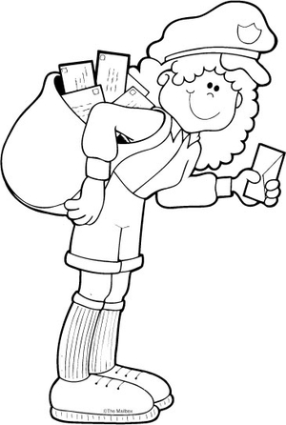
Without your assistance, I could not continue to experience the joy of reading. Thank you for helping me to never stop reading!

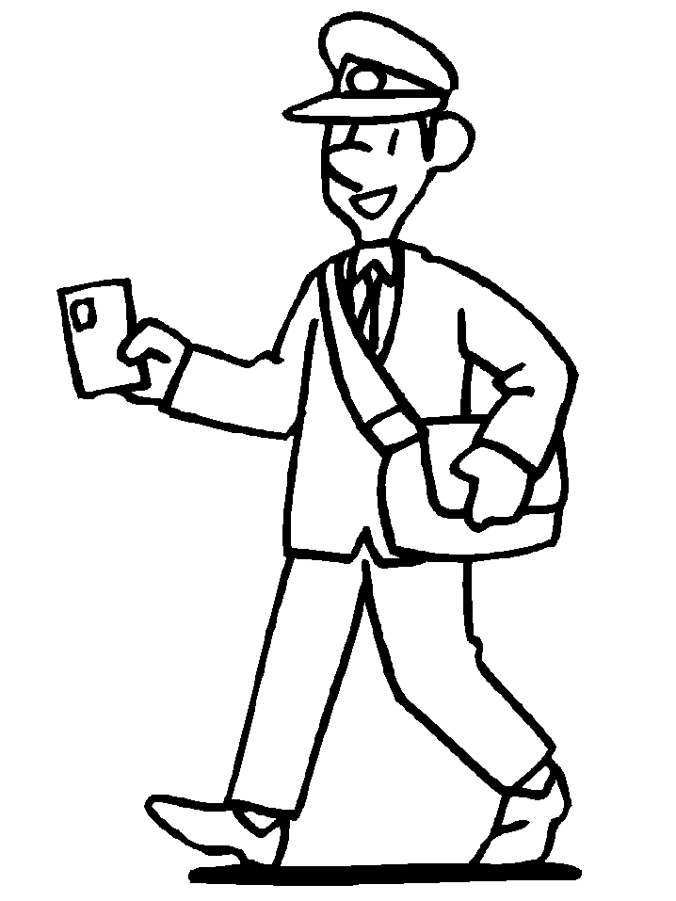
Your Friend,

Braille and Talking Book Library
California State Library
P.O. Box 942837
Sacramento, CA 94237-0001

ADDRESS SERVICE REQUESTED

Free Matter for the Blind and Physically Handicapped

BTBL News is written and edited by staff of the Braille and Talking Book Library at the California State Library. It is available in braille, audio file, through email, and in large print upon request, or through our website.

916-654-0640 or 800-952-5666 (toll-free in CA)
Email: btbl@library.ca.gov Website: btbl.ca.gov Catalog: btbl.library.ca.gov

Library Service Hours: 9:30 AM - 4:00 PM, Monday-Friday
Office closures: We will be closed May 28 (Memorial Day), July 4 (Independence Day), September 3 (Labor Day), Nov. 12 (Veterans Day observed), Nov. 22-23 (Thanksgiving).

Donations to BTBL are accepted at any time and are used to enhance and improve library services. In the case of memorials or donations in honor of a particular person or event, please include the name(s) and address(es) of those to be notified. Checks should be made payable to the California State Library Foundation and should include a note that the donation is for the Braille and Talking Book Library.
Donations should be sent to: California State Library Foundation, 1225 8th Street, Suite 345, Sacramento, CA, 95814-4809. Donations can also be made online at: cslfdn.org. Follow the link to "Join/Donate Online." There is a place to designate BTBL as the recipient.

