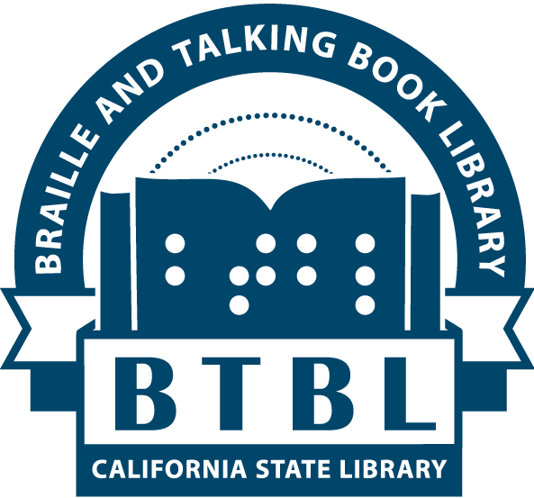 | BTBL News  Braille and Talking Book Library  California State Library, Sacramento, CA
New Series no. 20 (Fall 2018)
In This Issue:
- Director's Message
- Multiple Books on One Cartridge
- BTBL’s Summer Reading Program Results
- Assistive Technology Vendor Fair
- Statewide Voter Information Guide
- Californiana Studio Laying Down Tracks
- Bookshare Update and New Access to Open Library
- Never Pay Postage to Return Library Materials
- You Can Borrow Movies From Us
- Patron Spotlight: A Man of Many Talents
- BTBL User Advisory Council
- BTBL Staff Picks

A Message from Mike Marlin, Director

Festive Fall greetings from the accessible book-tropolis here in your state capital. It has been a busy year for BTBL with much to report since our last edition in May.

First and foremost, the era of the Recorded Cassette Talking Book and Cassette Book Machine is coming to an end. As of March 31, 2019, BTBL will cease all circulation of recorded cassettes (RCs in green containers) as well as support and distribution of cassette book machines. It has been ten years since the introduction of the digital talking book machine and talking books on digital cartridge (DBs), and after a decade-long transition, it’s time to say farewell to an obsolete twentieth century technology. The three main reasons for the termination of the cassette era in Northern California are as follows: 1) the insufficient number of parts and trained volunteers to adequately repair cassette players, 2) the unreliable condition of remaining cassette books, and 3) the new ability for BTBL to offer older, former cassette titles on customized digital cartridges through our Patron Centric Cartridge program (see next article). If you have questions about the grand finale of the cassette program, please contact your Reader Advisor.

Speaking of technology, staff of the National Library Service for the Blind and Physically Handicapped (NLS) presented a series of planned innovations at the NLS National Conference which took place this past June in Nashville, Tennessee. Research on the next generation of talking book machines continues, with focus on cellular/wireless delivery options, a text-to-speech (synthetic voice) engine, and potential integration with voice activation control systems such as the Amazon Echo (Alexa) device. A low cost refreshable braille display is also in the works, a development that will bring free braille eReaders to the current 35,000 braille readers nationwide. NLS is also working to support all network libraries to provide Duplication on Demand. Duplication on Demand will allow libraries to quickly duplicate physical copies of books in-house based on demand from patron requests, rather than continuously storing multiple physical copies of book titles on library shelves in case a patron requests them in the future. In general, NLS is focusing on transitioning to digital, cloud-based information storage capacity.

Finally, we are inching closer to the implementation of the Marrakesh Treaty to Facilitate Access to Published Works for the Blind, Visually Impaired, and Otherwise Print Disabled. The U.S. Senate ratified the international treaty in June and the House of Representatives ratified in late September. The final bill will now be on the way to the executive branch for signing. Once signed, the real work of sharing accessible books between countries will begin. Soon BTBL staff will join fellow authorized entities to learn best practices for lending and borrowing important works in a multitude of foreign languages as well as English. BTBL has created a Marrakesh promotional video (starring yours truly) which can be found at: tinyurl.com/CSLMarrakesh.

Multiple Books on One Cartridge

BTBL is proud to announce the launch of our Patron Centric Cartridge (PCC) program. A PCC allows for BTBL to put more than one book title onto one digital cartridge to ship out to you. This means that you could have a digital book cartridge mailed out to you that has 2, 4, 6, or more books on the cartridge! Imagine being able to receive the entire Harry Potter book series in one cartridge, or receive that new bestseller when all other library copies are checked out. It’s also a quick way to receive books marked as “Download-Only” in our online catalog if you don’t have a way to download.

The PCC program requires that you have working knowledge of the “Bookshelf” feature of our digital talking book machine. The “Bookshelf” feature is used to switch between multiple book titles on one cartridge and is used in 3 steps:

- Enter “Bookshelf” mode. With the PCC in the machine, press and hold the Play/Stop button until the machine says “Bookshelf” and announces the number of books found on the PCC (you can then release the Play/Stop button).
- Navigate to title. Single tap (don’t hold down) the FF button on the machine to navigate through the available titles. After each tap of the FF button you will hear the machine announce a title (e.g. “Book 1 Harry Potter and the Sorcerer’s Stone”). You may tap the RW button to navigate backwards to a previous book title.
- Select title. When you hear the book title you want to listen to announced, tap the Play/Stop button to begin listening to that book. When your book has begun playing, you have exited the “Bookshelf” mode.

You can return to Step 1 at any time if you wish to switch book titles again. The machine will remember your reading position in each title. A reminder of these Bookshelf instructions will play when you first plug a PCC into the machine.

To get a PCC, you must work with your Reader Advisor. Each PCC is tailor-made for the individual and your Reader Advisor will hand-select titles for you each time the PCC is sent out. The physical cartridge that is mailed will not have information about what titles are on the cartridge, but rather each PCC will be labeled to identify the patron it belongs to. Like most of our materials, to return a PCC to us, simply turn over the mailing label on the outside of the container and place the PCC in the mail.

If you feel a PCC may be for you, please contact your Reader Advisor to get started with our newest program.

BTBL’s Summer Reading Program Results

BTBL’s second ever Summer Reading Program concluded on August 31st. Thirty percent more readers participated compared to last year and they devoured over 460 books. We sent all participants either a Baskin-Robbins ice cream or Starbucks gift card. Let’s outdo ourselves next summer!

Assistive Technology Vendor Fair

BTBL is partnering with Sacramento’s Society for the Blind and NorthState Assistive Technology to sponsor a Resource and Technology Fair at Society’s 1238 S Street midtown Sacramento location on Saturday, November 3, 10AM to 2PM. Multiple vendors will be present with special presentations of “Wearable Technology” and “Reading in the Cloud: The Future of the NLS Service”. There will also be food and drawings with prizes. Register by email to rrueda@societyfortheblind.org no later than October 25. Please be sure to include the names, ages, and contact information for all attendees. Come on out to see what’s new in the field of accessible technology and resources!

Statewide Voter Information Guide

Another California statewide election is upon us; the general election is November 6, 2018. BTBL will again be offering the Voter Information Guide as a digital talking book (DTB). A month or so before the election, you should be able to download the DTB Voter Guide from our website, or contact us to borrow a copy on digital cartridge via mail. The Secretary of State offers the Voter Guide in MP3 audio format at voterguide.sos.ca.gov/en/alt-versions.

Californiana Studio Laying Down Tracks

In May we introduced our new studio coordinator, Christopher, and he has been busy working with longtime dedicated volunteers and other BTBL staff to move the needle forward. As a result, the newest BTBL narrated book in many years is now available on the Braille and Audio Reading Download (BARD) service. The book is DBC 07159 entitled Humboldt: Life on America’s Marijuana Frontier, which follows a journalist’s investigation of the region’s transition to a legal economy after years as an underground trade. Look for more BTBL local recordings in the coming months!

Bookshare Update and New Access to Open Library

On September 1, 2017, we launched the first year of a two-year pilot program providing free access to Bookshare service for 325 patrons statewide. BTBL is happy to announce that we have received funding for the second year (September 1, 2018 through August 31, 2019), providing a total of 500 seat licenses for interested patrons. If you participated in year one, your license will automatically continue into year two. If you no longer need your Bookshare license, please be sure to contact us so that we may give your seat to another user.

If you did not participate in year one and would like to sign up for year two of Bookshare, please contact your Reader Advisor. Because Bookshare is an online, download service, patrons who are comfortable and experienced with computers and file management are the ones most encouraged to partake of this ordinarily $50 per year service. It is very important to note that, unlike NLS talking books, Bookshare books are not narrated by human beings. The books are available in: 1) electronic braille files that can be read on refreshable braille displays; 2) text-to-speech (TTS) DAISY files; and 3) TTS MP3 audio files that can be played on the NLS digital talking book machine and on several third party commercial players. There is free online DAISY player software to listen to DAISY TTS files on one's computer as well as several apps for listening on mobile devices. Please visit Bookshare.org to learn more about the service.

Continuing on the download front, the California State Library has signed an agreement with Open Library (an initiative of the Internet Archive) that allows us to verify print disability eligibility for our patrons who have established an Open Library Internet Archive account. With a verified account, a patron can gain instant access to thousands of optical-character-recognition scanned, text-to-speech converted print books, including scholarly works. Check out the collection of books available at openlibrary.org/subjects/accessible_book. For more information on verifying your Archive.org account, please contact your Reader Advisor.

Never Pay Postage to Return Library Materials

Many patrons of the library already know that they can send their books back to the library without paying for postage by just turning over the handy return label on each book. But Free Matter for the Blind applies to just about anything you are sending to the library, including digital book machines or accessories like headphones. The only material patrons routinely send to the library that CANNOT be sent as Free Matter for the Blind are hand-written letters. So if you write us a letter, you do need to pay postage for it. Any order forms, braille letters, or large-print typed requests can be sent through Free Matter for the Blind, but remember to leave them unsealed to comply with Free Matter for the Blind regulations. To send something to the library postage free, just write “Free Matter for the Blind” in the upper right-hand corner of the envelope.

The Free Matter for the Blind program is funded by the U.S. Government, and each year Congress appropriates funds to the United States Postal Service (USPS) to subsidize the Free Matter for the Blind program. It’s important to remember that only the U.S. Postal Service participates in the Free Matter for the Blind program; attempting to send your library materials back through UPS or FedEx will result in paying for postage. If you have questions or are having trouble with your postal service, your Reader Advisor is here to assist you.

You Can Borrow Movies From Us

We’ve recently made some changes to our Descriptive Video Service (DVS) to make it even easier for you to borrow movies.

How DVS is the same:

- Each movie has a second audio track with a narrator's voice describing the action on the screen during breaks in the dialog and sound effects.
- We don’t loan equipment for playing movies—just the movies. You must have your own DVD player at home.
- Just like our books, the movies arrive in plastic mailing containers with a reversible mailing label on the outside for returning the movies to us postage-free.
- Order movies the same way you order books – call, mail, fax, email, or order online.

How DVS has changed:

- There is no application required – just ask your Reader Advisor to sign you up.
- Loan periods have increased from 2 weeks to 5 weeks.
- You can now sign up for movie subjects, such as “Westerns” or “Action/Adventure”, and we will automatically send you movies that match.
- We now have over 500 titles to choose from!

Whether you’re dying to see the 2018 Oscar-winner The Shape of Water, or you’d like to watch The Andy Griffith Show, or you’re in the mood for a family-friendly Disney movie--contact your Reader Advisor today to get started with our Descriptive Video Service.

Patron Spotlight: A Man of Many Talents

One of our longtime library customers, Timothy Taubold, lives and works in the Fort Bragg area. It has been a pleasure getting to know him and discover that along with so many of the people we serve, disability has not kept him down.

Despite legal blindness and dyslexia since he was a child, he has built homes, been a successful businessman, and is a multiple-award-winning artist.
Through the use of magnification devices he has created detailed characterizations of Mark Twain, Linda Ronstadt and Jimmy Hendrix. He also has sensitively painted the rivers and woods that greet him in his native northern California surroundings.

What he has accomplished is admirable under any circumstances, but what is truly astounding is that he is still creating award-winning work even though he is now completely blind. He carefully crafts impressionistic paintings using his knowledge and memory of color and form to generate art that is pleasing as well as surprisingly complex.

It might be of interest to note that we have several visually impaired artists highlighted in our reading room that is open to the public. Timothy Taubold is one such artist.

Thanks to Timothy and many others who remind us on a daily basis that we are not defined by our disabilities; it is our abilities that truly define us.

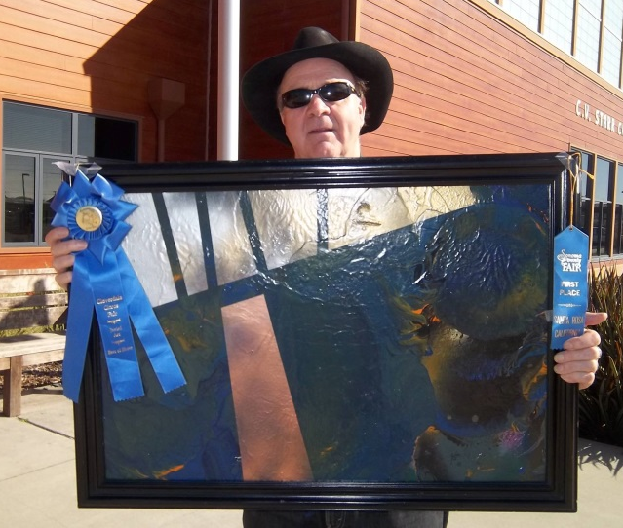
[image: Tim Taubold holding up his framed painting entitled Looking that won first place in the Sonoma County Fair]

BTBL User Advisory Council

If you are interested in giving back to the library with your own unique perspectives, please consider applying for the BTBL User Advisory Council. The Council meets quarterly in Sacramento and all expenses are reimbursed. Please visit www.library.ca.gov/btbl/advisory-council or contact Director Mike Marlin with any questions.

BTBL Staff Picks

The Rose Hotel a Memoir of Secrets, Loss, and Love from Iran to America by Rahimeh Andalibian DB 83335
“I found this autobiography not only to be a compelling family narrative, but it also thoughtfully addressed the religious and cultural divides that separate our two countries. After reading this book I have a new respect for immigrants and what they must endure. It was a great read and I couldn’t put it down.”
- Valerie, Reader Advisor
*contains violence

Hammer of the Gods the Led Zeppelin Saga by Stephen Davis DB 22994
“A must read for the true Heavy Metal/Hard Rock Fan, this book chronicles the greatest rock band on the planet during the 70’s (and some insist, myself included, of all time!): Led Zeppelin. This book covers the band in its entirety, from conception through its demise, from Robert and Jimmy’s first sit down to the death of John Bonham.”
- Christopher, Studio Coordinator
*contains strong language and some descriptions of sex

The Rosie Project by Graeme C. Simsion DB 78150, BR 20455
“A genetics professor that leads a very strict and structured life meets and falls in love with a free spirited woman who changes everything. I like this book because it’s a sweet love story.”
- Joan, Circulation
*contains some strong language and some descriptions of sex
The Last Black Unicorn by Tiffany Haddish DB 90101
“This New York Times Bestseller memoir from stand-up comedian and actress Tiffany Haddish is a hilarious, edgy, and touchingly personal collection of autobiographical essays. Growing up in an impoverished neighborhood, she uses laughter to shield herself and rise above adversity. If you like laughing, this book is a must.”
- Peggy, Reader Advisor
*contains strong language, some violence, and some explicit descriptions of sex.

Lily and the Octopus by Steven Rowley DB 85389, BR 21611
“If you are up for a good craughing (crying + laughing) session, check out this very cute story about a man and his beloved dachshund, Lily. I appreciated that the dog really seemed to shape his owner’s emotional development and increased his capacity for love. Yes, the dog ‘talks’ and is funnier than the humans. And fair warning, the Octopus from the title refers to Lily’s cancerous brain tumor, so you can imagine what direction the book heads.
All-in-all an amusing and cathartic read.”
- Sarah, Reader Advisor
*contains some strong language

Lafayette in the Somewhat United States by Sarah Vowell
DB 84158, BR 21439
“Having established herself as an exhaustive researcher and witty satirist, former NPR ‘This American Life’ writer/performer Vowell spares no one from her infectious humor in her latest biographical investigation into the most popular non-American American in the nation’s revolution, founding, and aftermath. The French-born Marquis de Lafayette, whose name graces plazas, parks, and other locales east of the Mississippi, and his peers like Jefferson and Washington with whom we are more familiar, provide grist for umpteen anecdotes and new revelations about revolutionary times. Vowell is one of my favorite forty-something historians and nouveau comic geniuses! Check out her other books especially Wordy Shipmates.”
- Mike, Director

Policeman Dave Robicheaux series by James Lee Burke
Start with: The Neon Rain (book 1) DB 26519
“I'm going to venture wide and recommend an entire series. James Lee Burke's portrayal of Dave Robicheaux throughout the series that begins with The Neon Rain gives us wonderful backstory steeped in ‘Louisiana Noir’ with an occasional side trip to Montana. The 21-book series is not for the faint of heart as there is almost always violence, but Burke's fine southern writing style makes them all worth a read and his characters stay with you long after the book plot has faded.”
- Mary Jane, Librarian
*contains strong language and some descriptions of sex.
Want to check out the whole series? Ask your Reader Advisor to load the entire series for you on your PCC!

Braille and Talking Book Library
California State Library
P.O. Box 942837
Sacramento, CA 94237-0001

ADDRESS SERVICE REQUESTED

Free Matter for the Blind and Physically Handicapped

BTBL News is written and edited by staff of the Braille and Talking Book Library at the California State Library. It is available in braille, audio file, through email, and in large print upon request, or through our website.

916-654-0640 or 800-952-5666 (toll-free in CA)
Email: btbl@library.ca.gov Website: btbl.ca.gov Catalog: btbl.library.ca.gov

Library Service Hours: 9:30 AM - 4:00 PM, Monday-Friday
Office closures: We will be closed Nov. 12 (Veterans Day observed), Nov. 22-23 (Thanksgiving), Dec. 25 (Christmas Day), Jan. 1 (New Year’s Day), Jan. 15 (MLK Day).

Donations to BTBL are accepted at any time and are used to enhance and improve library services. In the case of memorials or donations in honor of a particular person or event, please include the name(s) and address(es) of those to be notified. Checks should be made payable to the California State Library Foundation and should include a note that the donation is for the Braille and Talking Book Library.
Donations should be sent to: California State Library Foundation, 1225 8th Street, Suite 345, Sacramento, CA, 95814-4809. Donations can also be made online at: cslfdn.org. Follow the link to "Join/Donate Online." There is a place to designate BTBL as the recipient.

