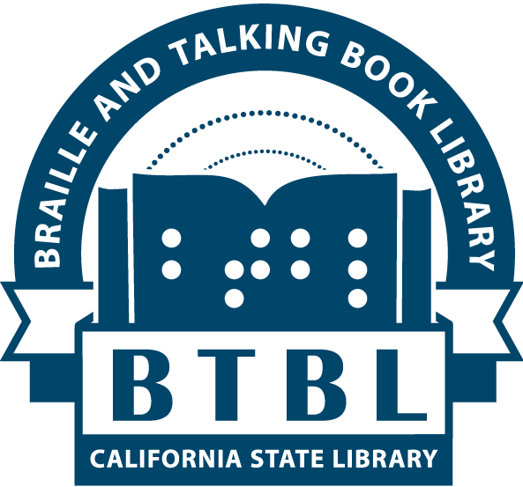
BTBL News
Braille and Talking Book Library
California State Library, Sacramento, CA

Special Edition (April 2020)

In This Issue:
- Director's Message
- Offline Stay-At-Home Resources

A Message from Mike Marlin, Director
Due to the novel coronavirus (COVID-19), and steps to mitigate it taken by the California Department of Public Health, since March 20 we have closed all California State Library operations except online services.
For BTBL patrons, this means staff are teleworking from home and so there is a temporary suspension of readers’ advisory and mail circulation services. We will not be mailing any materials (no books, no braille, no movies, no magazines, no machines) after Friday, March 20. We are also unable to receive any returned mail materials from you at this time. Please do not send any library materials back until you are notified we are accepting materials by return mail.
When events stabilize and we return to our physical location and begin braille and talking book mail circulation once more, we will notify patrons through our phone system, mail, email, website, and social media. Although our Reader Advisors are currently unreachable by phone and unable to make direct phone calls to patrons, you may occasionally call us at 800-952-5666 for recorded updates, or to simply check if we are back in the office! Otherwise, you can reach BTBL staff via email at btbl@library.ca.gov. Or, sign up for BTBL Updates email alerts at library.ca.gov/mailing-lists.
While mailing operations are suspended, you can still download talking books to an iOS, Android, or Kindle Fire device for easy playback through the Braille & Audio Reading Download (BARD) service. A long-distance friend or family member may even be able to download books to a USB drive on your behalf, and then mail the USB drive to you for playback in your digital player!
To get started with BARD visit nlsbard.loc.gov/CA1A/ApplicationInstructions.html.
For assistance with BARD, please email our staff at btbl@library.ca.gov.
Please accept this special edition of BTBL News as a pandemic-related placeholder for a future regular edition as soon as we’re back up and running.
We understand the hardship this situation may cause for you and apologize for any inconvenience. If you have questions or wish to learn more, please contact us by email at btbl@library.ca.gov as we won’t be able to respond to your voicemail message until we are back up and running. Stay safe!

Offline Stay-At-Home Resources
No internet required ideas for staying busy while the library is closed.

Complete the Census
The questionnaire takes less time to complete than drinking a cup of coffee! And while the census questionnaire itself won’t be available in braille, people who are blind or visually impaired can take advantage of the online (my2020census.gov) and phone (844-330-2020) options.

American Council of the Blind Radio
ACB Radio streams up-to-date and relevant information worldwide for persons who are blind or have low vision, and provides shows produced by blind programmers. You can listen to ACB Radio with an ordinary telephone by calling 712-775-4808. Once connected, you can choose which stream you wish to listen to. If there isn’t a talk program currently scheduled, you will hear a wide variety of music—sometimes performed by blind musicians or composers.

NFB-NEWSLINE®
NFB-Newsline® is a free audio news service offering timely access to more than 500 newspapers/magazines, emergency weather alerts, and more. Content can be accessed using a basic touch-tone telephone, an iOS device (such as an iPhone, iPad or iPod touch), an NLS-compatible digital talking book player (with the help of an internet-enabled device such as a computer), and now Amazon Alexa devices! Register for NFB-Newsline® at 866-504-7300 or let us help you register by emailing btbl@library.ca.gov.

COVIA Well Connected AKA Senior Center Without Walls
This free telephone service offers programming that seniors (60+) can dial into and participate or socialize with other seniors. The Well Connected telephone and online community is made up of participants, staff, facilitators, presenters, and other volunteers who care about each other and who value being connected. Whether you like art or zoology, music or meditation, or are looking for a friendly chat, there is a program for you. Well Connected members call in via a toll-free number at a scheduled time (with options to connect via computer, tablet or mobile device). Register for Well Connected at 877-797-7299 or covia.org/services/well-connected.

Dial-A-Bible Story
All the stories of the Bible via phone. After calling 559-670-1877, you can enter a story number 1, 2, 3...260 for full-length stories, 1001, 1002, 1003…1260 for 90-second stories. To control story playback: 0 = Skip to end of story, 2 = Reverse 30 seconds, 3 = Forward 30 seconds, 8 = Pause.

Crisis and Friendship Line for Seniors
An accredited crisis line for people aged 60 years and older, and adults living with disabilities, this hotline offered by the Institute on Aging is focused on lonely older adults. Keep isolation, anxiety, fears, or boredom at bay by calling 800-971-0016 to speak with volunteers specialized in offering a caring ear and having a friendly conversation with depressed older adults.

Braille and Talking Book Library Free Matter for the
California State Library Blind or Handicapped
P.O. Box 942837
Sacramento, CA 94237-0001
ADDRESS SERVICE REQUESTED
BTBL News is written and edited by staff of the Braille and Talking Book Library at the California State Library. It is available in braille, audio file, through email, and in large print upon request, or through our website.
916-654-0640 or 800-952-5666 (toll-free in CA)
Email: btbl@library.ca.gov Website: btbl.ca.gov Catalog: btbl.library.ca.gov
Library Service Hours: 9:30 AM - 4:00 PM, Monday-Friday
Office closures: We will be closed May 25 (Memorial Day), September 7 (Labor Day), November 11 (Veteran’s Day), November 26-27 (Thanksgiving), December 25 (Christmas).
Donations to BTBL are accepted at any time and are used to enhance and improve library services. In the case of memorials or donations in honor of a particular person or event, please include the name(s) and address(es) of those to be notified. Checks should be made payable to the California State Library Foundation and should include a note that the donation is for the Braille and Talking Book Library.
Donations should be sent to: California State Library Foundation, 1225 8th Street, Suite 345, Sacramento, CA, 95814-4809. Donations can also be made online at: cslfdn.org. Follow the link to "Join/Donate Online." There is a place to designate BTBL as the recipient.

