Table of Contents
Executive Summary 2
Introduction 3
Background 3
Survey Highlights 4
Survey Question: What Is Your Library Doing to Support Sustainability? 5
Survey Question: What kinds of sustainable improvements would you like to see at your library (or California libraries in general) in the future? 6
Survey Question: Rank the importance of current sustainability issues for California libraries 7
Survey Question: What barriers prevent your library from addressing sustainability? 8
Survey Comments 9
Libraries as Resiliency Hubs 9
California Libraries Becoming Certified 9
Interviews with California Public Library Leaders 10
Sustainability & Partnerships Across the State 11
Energy Efficiency Toolkits 11
Seed Libraries 11
Contra Costa County Library: Sustainable Leaders in Action 12
Alameda County Library: Induction Cooktops & More 12
Redwood City Public Library: Rooftop Bees & Programs 13
Yolo County, Winters Public Library: Learning Garden 13
Berkeley Public Library: Zero Net Energy & Electric Vehicles 14
Santa Clara County Library: EV Go Go Biblios 14
San Francisco Public Library: Green Stacks and Bookmobile 14
Summary & Recommendations 14
Top Five Actions to move sustainability forward in California libraries 15
Acknowledgements…………………………………………………………………………………..16

“We don’t have to engage in grand, heroic actions to participate in change. Small acts, when multiplied by millions of people, can transform the world.”
Howard Zinn, historian, author, and playwright

Executive Summary
This report examines current sustainability practices in California libraries. A survey designed on sustainability was administered in April and May of 2022. The survey gathered baseline data and measured the current mindset of library staff on sustainability topics. Of the 266 responses, over 98% stated that the issue of sustainability was either “very important” or “somewhat important” to them and their community.

Survey data and interviews show that over the last few years more public libraries in California are starting to provide programs or services with sustainability in mind. California public libraries have begun to raise awareness on the climate crisis, food insecurity, water conservation, waste reduction, and more. Many current examples of sustainable practices in California public libraries are highlighted in this report.

The goal for the Sustainable California Libraries project is to bring libraries together to collectively share local and statewide opportunities, programs, ideas, resources, and connections. The United Nations 2030 Agenda for Sustainable Development call to action specifically notes the need for “increased access to information and knowledge” and “universal literacy” as key for reaching sustainability goals. American Library Association has made sustainability a core value and the Council Committee on Sustainability has also released a call to action. California libraries should continue to serve and grow as models and partners in sustainability.

The Top Five Actions to move sustainability forward in California libraries include:

- Develop a collective statement/commitment to sustainability
- Promote and grow sustainability related trainings
- Encourage local and state involvement in funding opportunities that support climate resilience and sustainable library programming and services
- Take advantage of opportunities for libraries to serve as sustainability models through buildings and services
- Increase opportunities for library staff of all levels to connect around topics of climate resilience and sustainability

Introduction
Libraries are the hub of their communities and a source of valuable information for community members. The American Library Association’s Public Programs Office released a briefing from the Council Committee on Sustainability on June 22, 2022, with a strong focus on climate change, stating “libraries should reflect a commitment to sustainability as a core value.”

According to the International Federation of Library Associations and Institutions (IFLA), “The library is the only place in many communities where people can access information that will help improve their education, develop new skills, find jobs, build businesses, make informed agricultural and health decisions, or gain insights into environmental issues.” Libraries bring the community together and promote sustainability through programming and outreach.

The Sustainable California Libraries project is connecting libraries across the state and creating awareness. Through a survey, two networking sessions, professional interviews, and the work of an advisory board, the project has opened opportunities for libraries to become more involved with sustainability.

Background
“Without environmental sustainability, economic stability and social cohesion cannot be achieved.”
Phil Harding, archaeologist
On April 22, 2022, California’s Office of the Governor announced a list of strategies to reach adoption of a 30×30 conservation goal to conserve 30% of California’s lands and coastal waters by 2030 in order to combat climate change and safeguard California’s diverse ecosystem. Governor Gavin Newsom noted that his strategy is to create more access to nature and reduce reliance on fossil fuels.

Newsom stated, “No challenge poses a greater threat to our way of life, prosperity, and future as a state than climate change… Strong partnerships across the board will be critical to these efforts.
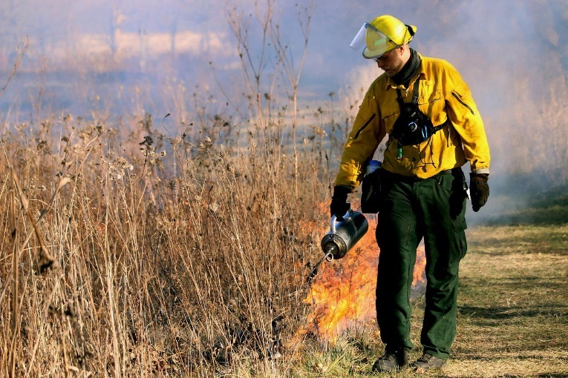

California’s most recent Climate Change Assessment emphasizes that climate change needs to be addressed now.

“In the last decade, Californians have endured severe droughts, floods, historic wildfires, rising seas, and record temperatures all driven by climate change.” The choices Californians make now will deeply affect the state’s future.

During her 2021-2022 tenure, American Library Association President Patty Wong maintained a strong focus on sustainability. Wong also wanted to see doors open “for public, academic, and school libraries across the country to participate in a sustainable library certification program.”

According to the latest California Public Library survey, there are 115 LEED certified library locations in California. In addition, the California Green Business Network has certified over 25 California libraries, representing 3% of all libraries in the State. Currently, one public library jurisdiction has signed up for the Sustainable Libraries Initiative certification process. The Sustainable Libraries Initiative and California Green Business Network certifications evaluate practices and make recommendations for improvements in a variety of environmental impact areas such as energy conservation, water use, waste reduction, and pollution prevention. Both certification paths are highly recommended for California libraries to become more sustainable institutions.

Survey Highlights
A survey on sustainability was created to collect responses from public library professionals, in a variety of roles, across the state of California. The survey results provided a snapshot of information, showing that many library staff are already engaging in meaningful work in the area of sustainability. The results also shed light on areas where improvement is needed, such as forming partnerships, creating Green Teams, and performing green audits. The 266 survey responses confirmed that many libraries already have knowledge on the importance of sustainability, as almost 70% responded that sustainability was very important to them and to their community and 30% of the responders stated that sustainability was a somewhat important issue.

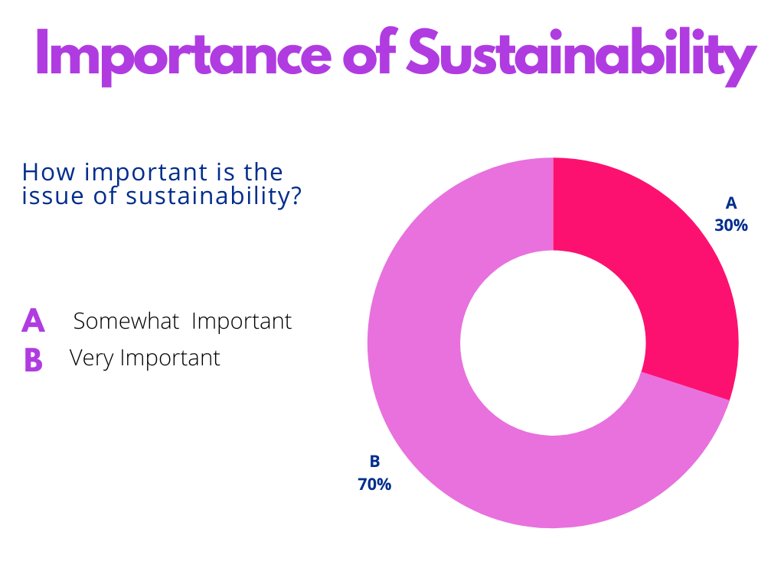

Survey Question: What Is Your Library Doing to Support Sustainability?
Over 80% of participants noted they have been supportive of the Three R’s: Reduce, Reuse, and Repair/Recycle, including recycling in public and staff areas, reuse of materials, providing Fix-it clinics and more. Almost 40% of responders stated they have hosted community events that focus on food waste, composting, or zero waste living. Approximately 35% of libraries in California are working on drought-tolerant landscaping plans and/or utilizing rain barrels.

30% of survey participants noted that their library system has started a Library of Things, offering a variety of items for patrons to borrow rather than purchasing a new or one-time use item. The Sacramento Public Library has a Library of Things collection that offers a range of items, including musical instruments, sewing machines, button makers, backyard bird watching backpacks, toys, seeds, sewing machines, and new technology, like virtual reality headsets. Contra Costa County Library also has a Library of Things that lends out ukulele kits, outdoor adventure backpacks, tools, story kits, and wi-fi hotspots.
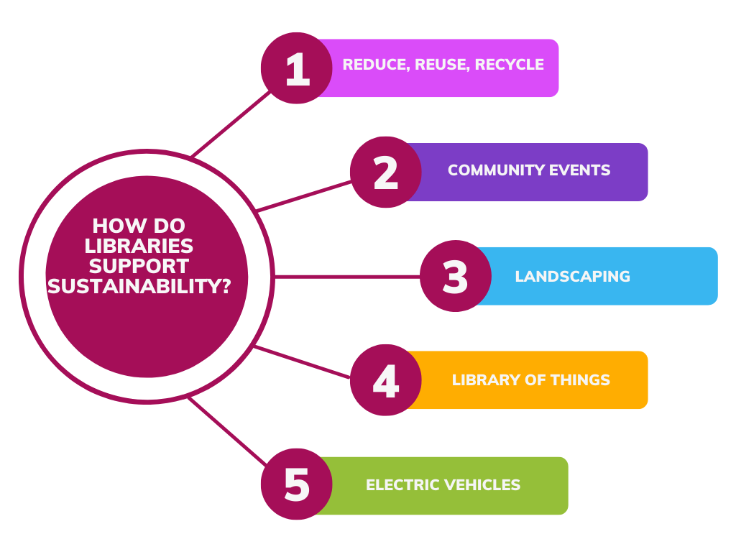

Survey Question: What kinds of sustainable improvements would you like to see at your library (or California libraries in general) in the future?
80% of survey participants selected energy-saving & carbon-reducing measures as the
area they would most like to see improvements. 75% of participants chose green architecture, including library retrofits and more LEED certified buildings. 65% chose electric vehicles, bookmobiles, and chargers. 63% chose sustainable and digital collections, including programs to keep books out of landfills. 33% chose Green Teams.

Participants further noted the following as improvements they would like to see:
- Drought tolerant landscaping, native plants, pollinator-friendly gardens
- Community gardens for local food
- Plant-based local meals at library events
- More sustainable crafts and classes
- Comprehensive recycling programs
- Solar panels and energy storage
- Less paper/flyers, move to paperless receipts, QR codes, biodegradable library cards
- Composting options available for food waste
- Seed libraries and programming about food and biodiversity

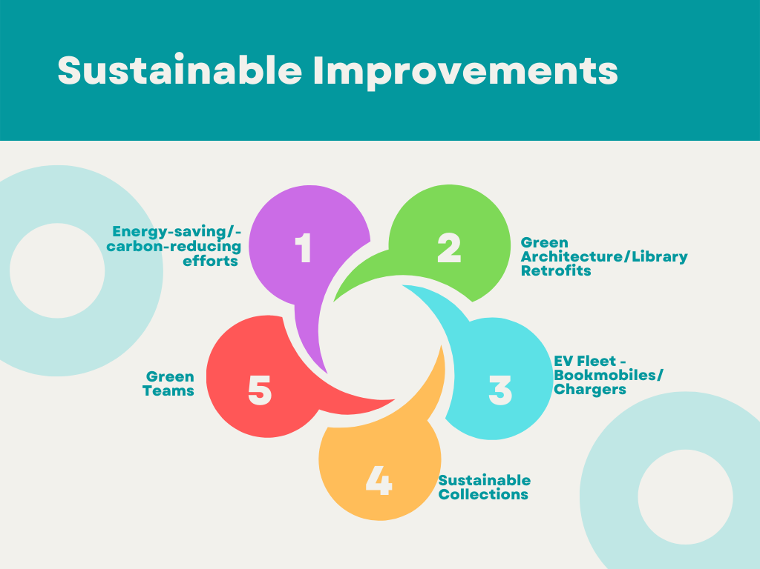

Survey Question: Rank the importance of current sustainability issues for California libraries
“Libraries need to do more to educate the public about sustainable living and show them that small, gradual steps can make a difference.”
Anonymous survey participant, 04/09/22
Participants were asked to rank the importance of current sustainability issues for California libraries. Responders ranked the issues in order of importance, also noted in the image below, as follows: (1) Water Resources (2) Climate Change (3) Justice/Education & Outreach (4) Waste Reduction (5) Landscaping & Grounds and (6) Food Consumption & Waste.

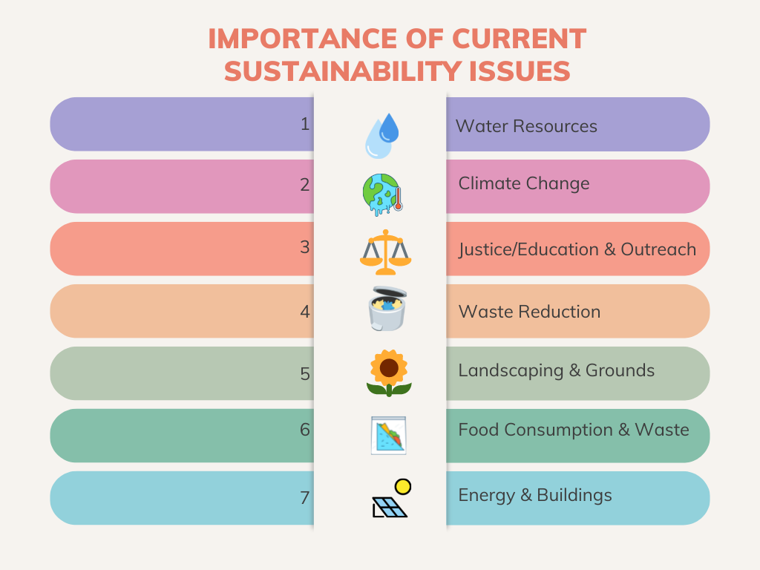

Survey Question: What barriers prevent your library from
addressing sustainability?
The top three barriers noted were: lack of staff time, financial barriers, and lack of knowledge. 80% of the participants said that they did not have enough staff time to focus on sustainability. One participant noted, “Not just lack of time, but lack of staff period.” 36% of participants found that financial barriers were an issue. Lastly, lack of knowledge was also a barrier for many libraries. 25% of participants noted that there was a lack of general knowledge around sustainability.

Survey Comments
Below are a few featured comments:

- Drastic action needs to be taken to give this planet a fighting chance.

- Any level of change is substantial and having a state-wide program that truly caters to each library system could have bigger impacts than if it was only offered to those that have the resources to join.

- All libraries should readily offer resources to patrons to help them find actionable steps to reduce the negative impacts humans have on the environment. I hope to see statewide initiatives and funding working towards this goal.

Libraries as Resiliency Hubs
Libraries can act as resiliency hubs to provide support during times of extreme weather as a result of climate change, air quality issues from wildfires, and even the COVID-19 pandemic or other major societal disruption. Lawrence Nussbaum, representative of the California Green Business Network said, “This is what libraries do, they pivot, they learn, they adapt, and they assist their community.” Libraries stand out as community organizations that can readily serve as second responders. They can be cooling centers during extreme heatwaves, provide backup energy for emergencies, act as communication facilitators, and educate businesses and residents on emergency preparedness and resilience strategies throughout the year.

Sarah Solis, Facilities Manager at San Diego County reflected, “It’s such a natural progression of what the library already does.” Solis also noted that preparing for emergencies is a central element for resiliency. Libraries across California are developing new emergency plans, partnering with organizations to share resources and identify funding resources, and reframing the library’s role as a resiliency hub.

California Libraries Becoming Certified
When Library Director Migell Acosta found out that the Sustainable Libraries Initiative certification program was being expanded outside of New York, he decided to join. San Diego County Library is the first library system in California to work on receiving certification through the Sustainable Libraries Initiative. According to Solis, San Diego County Library is on track to meet the City’s 2030 energy consumption reduction goals.

The California Green Business Network (CAGBN) is a statewide agency that works with city, county, and state agencies to meet sustainability goals by assessing practices related to various environmental impacts, providing recommendations and resources for continual improvement, and helping communicate sustainability accomplishments to the public. CAGBN operates in partnership with local jurisdiction sustainability programs, helping to streamline the green business certification process and save time. At the Sustainable California Libraries Networking Session #2, Julianna Robbins, Library Programs Consultant for the California State Library noted, “This is a great way for libraries in California to start to form a plan and present it to leadership.”

Interviews with California Public Library Leaders
In late Spring 2022, sixteen interviews were conducted with public library professionals across California. Interviewees shared their experiences, challenges, and successes in working toward sustainable solutions. Below are select highlights from the interviews:
Damon Hill, Interim Deputy Director at Marin County Free Library shared successes on being greener in the workplace and working toward a 2025 zero-waste goal. Hill commented on how Marin County library staff are taking this challenge seriously, including plans for a green team that will help them reach the zero-waste goal.

Ben Gomberg, Division Director for Alameda County Library spoke about partnerships and how libraries should actively partner with governmental agencies and non-profit organizations. Gomberg said, “Staff has energized around bringing sustainability education to the library, making learning about growing food, pollinators, and ecology a part of the library experience.”
Cathy Crosthwaite, Deputy Director for Sacramento Public Library shared her passion for sustainability and detailed her journey bringing electric vehicles to the library by working with Sacramento’s Air Quality Management District and Clean Car Coalition. Crosthwaite explained, “I've been able to create so many connections and partnerships and build awareness.” Crosthwaite is committed to access and has a vision to someday offer library patrons the option to check out an electric vehicle with their library card.

Shawn Thrasher, Library Director for Ontario City Library was excited to talk about the possibilities of sustainability programs and projects. Thrasher spoke of his recent work with Ontario Learns and the programs offered on how to save money and conserve water. He also mentioned that the libraries he oversees all have new composting cans for staff and patrons.

Chris Cooper, Director of Library Services for Humboldt County Library has a focus on sustainability. Humboldt has 11 libraries, including the Kim Yerton Memorial, a tribal library also known as the Hoopa Library. There is a possibility of the Hoopa Library piloting a Library of Things soon, with the collection including fishing poles and both power and hand tools. This collection will be extremely valuable to the Hoopa community, an underserved area in Humboldt County.

Sustainability & Partnerships Across the State
Creating partnerships with organizations allows both libraries and organizations to reach a wider audience. Examples of partners might include climate change or zero waste nonprofits, wetlands organizations, wildlife preservation groups, and city/county sustainability, electricity, water, waste, and recycling departments. Below are examples of public libraries and partners working for a more sustainable California.

Energy Efficiency Toolkits
Jessica Cadiente, Library Director at Santa Barbara Public Library, shared a program where patrons can check out a DIY Home Energy Savings toolkit at participating libraries. Cadiente is also an Advisory Group member for Sustainable California Libraries.

Jose Gayton, Librarian at the Santa Maria Public Library highlighted a similar service. The DIY Energy kits debuted in May 2022 with a free demonstration. The toolkits are provided through a partnership with the Tri-County Regional Energy Network (3C-REN). Gayton said, “This is a great way to let people know that the library has these items and also a good way to support connections.”

Santa Clara City Library partnered with Silicon Valley Power to create an Energy Savings & Efficiency Tool Lending Collection that can be borrowed from the Central Park Library. The most popular item is the kilowatt meter. Librarian Katie Carter says that this energy saving tool collection “is a good fit for our library” and great for the community.”

Seed Libraries

Destiny Rivera, Information and Access Services Librarian at Menlo College in Palo Alto created a seed library when she worked at the Ocean Beach Library in San Diego in 2019. She started with one repurposed card catalog, seed packets, and a lot of creativity. Rivera partnered with different organizations, including Master Gardeners, Cabrillo Community Garden, Latinx Cultural Center, and Chia Café Collective.

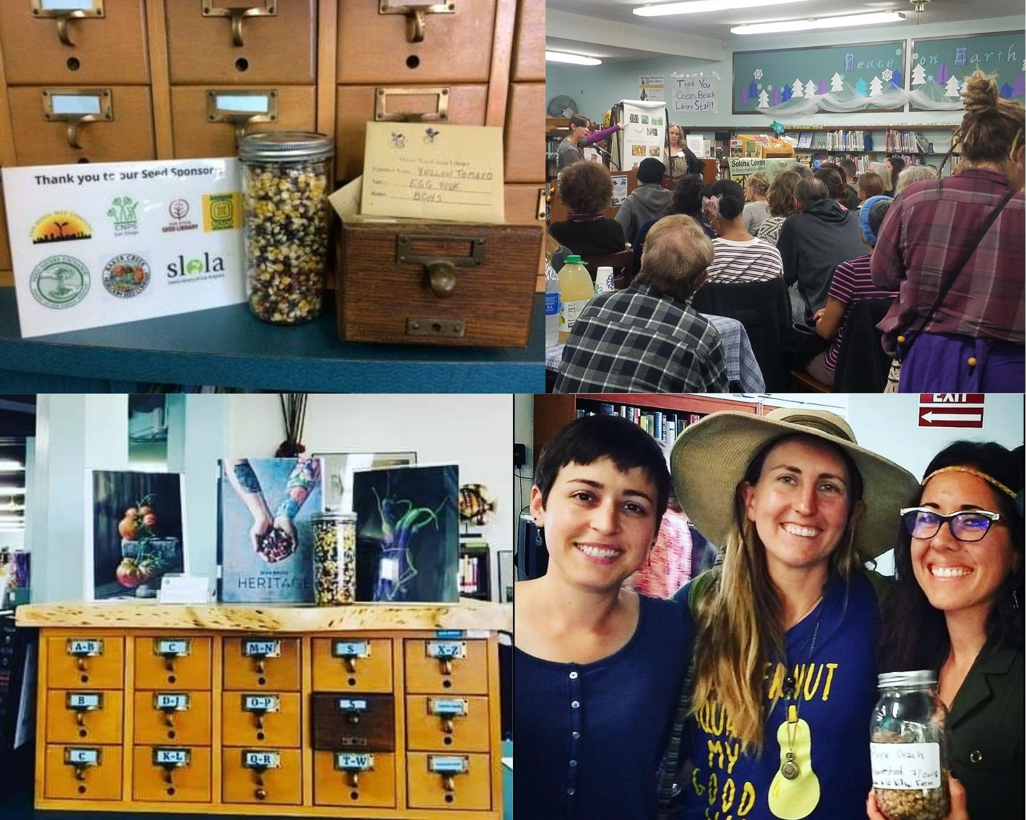

Oakland Public Library’s Seed Gardens were recently featured in an article that covered both their seed libraries and other gardening programs including free “grab n grow” kits.

Ree Satti, Library Assistant at the Concord Library in Contra Costa County recently started a Seed Center for patrons to check out local seeds. Satti’s interest with the Seed Center began when she started a program with take-home kits. Satti said, “We started our Seed Center with generous donations from other library branches that had seeds to spare, and the efforts of our wonderful volunteers.”

Contra Costa County Library: Sustainable Leaders in Action
Jacqueline Higgins, Librarian at the Antioch Library in Contra Costa County currently works with Sustainable Leaders in Action, planning quarterly virtual programs. Higgins also works closely with the City of Antioch’s Environmental Resources Division and the CivicSpark associate. Higgins remarked, “What I hear over and over again from our program attendees is that these presentations are so caring and thoughtful and are giving them hope for the future, which is really important in our current state.”

Alameda County Library: Induction Cooktops & More
Ben Gomberg, Division Director for Alameda County Library has worked with several partners on sustainability projects over the last few years. Gomberg shared his thoughts on working with partners and the idea of “leveraging our library buildings as an exhibit hall.” The Centerville Library developed a Learning Garden through partnerships with a local ecology organization, a farming nonprofit, and the Boy Scouts. At the Castro Valley Library, staff worked with a local group that reached out to him about partnering. Together they added a seed library and created a pocket park.
Alameda County Library recently started lending induction cooktops at eight branches. Division Directors Brian Edwards and Ben Gomberg partnered with East Bay Community Energy & Acterra to create the lending programs.

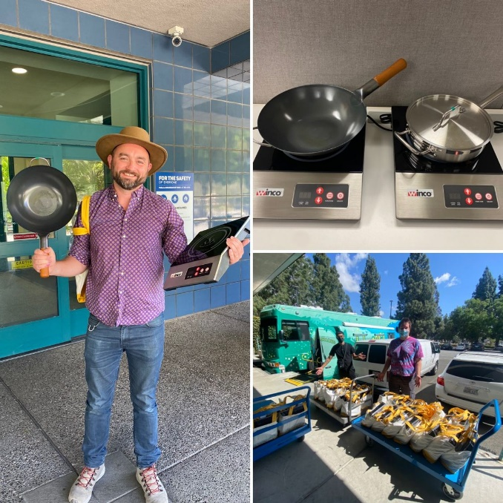

Similar programs exist at Santa Maria Public Library and the Sunnyvale Public Library in Santa Clara County. Sunnyvale has an induction cooktop program called “Cool Cooktops” which demonstrates how induction cooking can be healthier, safer, greener, and 40% more energy efficient.”

Redwood City Public Library: Rooftop Bees & Programs
The Redwood City Library’s Rooftop Bees program started in 2018 when local beekeeper Kendal Sager partnered with the library. Library Director Derek Wolfgram has been dedicated to this program from the start. During the summer, there are three hives, and over 150,000 bees on the library’s roof. The Redwood City Library’s Friends of the Library recently harvested and jarred this year’s batch of honey.

Yolo County, Winters Public Library: Learning Garden
Ashleigh Torres, Branch Manager at the Winters Public Library in Yolo County spoke about their Learning Garden (see cover page image) and related programming. The Winters Library offers storytime in the garden twice a month and was recently selected from a nationwide pool of applicants as a recipient of the #PlantWildflowers grant – an education and action initiative to highlight the role of pollinators and spark local efforts to support wild pollinators. In May 2022, the library partnered with the UC Master Gardeners to host a variety of events for all ages: Plant a Flower Day, Earth Day extravaganza, World Bee Day, and several all-ages presentations on pollinators.

Berkeley Public Library: Zero Net Energy Goals
Berkeley Public Library plans to become zero net energy by 2050 or before. The West branch, built in 2014, is a zero net energy building that actually produces more power than it uses. The 9,400 square-foot building utilizes solar panels, radiant heating and cooling, windows and skylights, a wind chamber, and large ceiling fans.

Santa Clara County Library: Electric Go Go Biblio
In 2018, the Santa Clara County Library District introduced four new mini bookmobiles to expand outreach into each of its communities. Named “Go Go Biblio,” three of these electric vehicles are based at the Cupertino, Los Altos and Saratoga libraries. The fourth vehicle is shared between Campbell, Gilroy, Milpitas, and Morgan Hill. The mission for these electric bookmobiles is to share the love of reading and learning with the public through their cargo of books and other media.

San Francisco Public Library: Green Stacks and Bookmobile
San Francisco Public Library hosts Green Stacks, a unique partnership with their Friends group, San Francisco Environment (a department of the City and County of San Francisco) and the Wallace Stegner Environmental Center. Green Stacks strives to inspire and inform users about greener living with events, booklists, resources, and examples from libraries. The library also operates a one-of-a-kind bookmobile that uses “natural air flow and light, and is equipped with solar panels, sustainably forested wood, recycled content carpet, and a hybrid generator that turns off when fully charged.”

Summary & Recommendations
“Alone we can do so little; together we can do so much.”
Helen Keller
The goal for the Sustainable California Libraries project is to bring libraries together to collectively share local and statewide opportunities, programs, ideas, resources, and connections.

The United Nations 2030 Agenda for Sustainable Development call to action specifically notes the need for “increased access to information and knowledge” and “universal literacy” as key for reaching sustainability goals.”

ALA has made sustainability a core value and the Council Committee on Sustainability has also released a call to action.

Project Drawdown, a nonprofit organization has been helping to get the word out about how we can reach “drawdown” and reverse climate change. Their Climate Solutions at Work is a how-to guide that explains that “Every job is a Climate Job”.
In May and June 2022, two Networking Sessions were scheduled through the Sustainable California Libraries initiative. The first networking session on May 10, 2022, featured Destiny Rivera who shared her seed garden programming experience, and Ben Gomberg who shared Alameda County Library’s sustainability partnerships. The second networking session on June 29, 2022, featured Sarah Solis, San Diego County’s Facilities Manager who shared her experience with green buildings, zero net energy, and the Sustainable Libraries Initiative and Lawrence Nussbaum from the Green California Business Network, who spoke about sustainable library certification.

Top Five Actions to move sustainability forward in California Libraries:

- Statewide groups and agencies in collaboration with national partners, should coordinate a collective statement/commitment to sustainability, using the Green Libraries Manifesto or similar documents as models.
- Promote and grow sustainability related trainings and opportunities including Niche Academy’s Sustainable Thinking for the Future of Libraries webinar with Rebekkah Smith Aldrich and a possible California Libraries Learn Sustainability Series on sustainable programs, partnerships, and services.
- Develop and encourage local and state involvement in funding opportunities that support climate resilience, climate adaptation, and sustainable library programming and service including BayREN’s Bay Area Resilient Libraries Networking Initiative and the California Strategic Growth Council’s Regional Climate Collaboratives program among others.
- Take advantage of opportunities for libraries to serve as sustainability models with library buildings and services, by partnering with state and local programs to install electric vehicle chargers, increase electric vehicle bookmobile utilization, install solar panels, encourage energy efficient upgrades, and promote green building construction.
- Increase opportunities for library staff of all levels to connect around topics of climate resilience and sustainability, develop model programs for the Sustainable California Libraries grant opportunity, encourage membership in climate and sustainability related professional interest groups, associations. and roundtables; and continue building capacity for leadership that centers sustainability.

Acknowledgements

This publication was prepared through a collaboration between the California State Library and Pacific Library Partnership. Principal author: Kimberli Buckley, Library Manager, Concord Library; University Lecturer, San Jose State University
Sustainable California Libraries would also like to acknowledge the survey participants who provided feedback, the Sustainable California Libraries Advisory Board, Networking Session panelists and participants, and the library professionals interviewed for this report.

This publication is supported in whole or in part by the U.S. Institute of Museum and Library Services under the provisions of the Library Services and Technology Act, administered in California by the State Librarian.

Photo Credits
Cover photo: Butterfly release celebration; Ashleigh Torres, Winters Library
Page 4: Firefighter, Pixabay #5856332
Page 11: Seed Libraries; Destiny Rivera, Menlo Park College
Page 12: Induction cooktops; Brian Edwards, Alameda County Library

sdgs.un.org/2030agenda
ala.org/news/member-news/2022/06/call-action-climate-change-libraries
ifla.org/how-do-libraries-further-development
gov.ca.gov/2022/04/22/governor-newsom-joins-groundbreaking-for-worlds-largest-wildlife-crossing-as-state-launches-nature-based-strategies-to-fight-climate-change-and-protect-biodiversity/
opr.ca.gov/climate/docs/20220629-OPR_ICARP-5th_Assessment_Fact_Sheet.pdf
https://www.ala.org/news/member-news/2022/06/call-action-climate-change-libraries
llibrary.ca.gov/services/to-libraries/statistics/
saclibrary.org/Books-Media/Specialty-Checkouts/Library-of-Things
ccclib.org/library-of-things/
Lawrence Nussbaum, California Green Business Network. Interviewed by J. Robbins & K. Buckley. 4/27/22
Solis, Sarah, San Diego County Library. Interviewed by K. Buckley. 5/5/22
Robbins, Julianna. Networking Session #2. 6/29/22 https://www.library.ca.gov/services/to-libraries/sustainable/
Gomberg, Ben, Alameda County Library. Interviewed by K. Buckley. 5/6/22
Crosthwaite, Cathy. Sacramento Public Library. Interviewed by K. Buckley. 4/26/22
Crosthwaite, C. Sacramento Public Library. Interviewed by K. Buckley. 4/26/22
Thrasher, Shawn Ontario Public Library. Interviewed by K. Buckley. 6/30/22
Cooper, Chris, Humboldt County Library. Interviewed by K. Buckley. 7/1/22
Gayton, J, Santa Maria Public Library. Interviewed by K. Buckley. 5/13/22
Carter, K, Santa Clara Public Library. Interviewed by K. Buckley. 5/23/22
Rivera. D. Networking Session #1. 5/10/22
Civileats.com/2022/04/25/public-libraries-are-making-it-easy-to-check-out-seeds-and-plant-a- garden/
Satti, R. Contra Costa County Library. Interviewed by K. Buckley 6/30/22
Higgins, J. Contra Costa County Library. Interviewed by K. Buckley. 6/15/22
Gomberg, Ben, Alameda County Library. Interviewed by K. Buckley. 5/6/22
sunnyvale.ca.gov/your-government/city-initiatives/sustainability/cool-cooktops
redwoodcity.org/departments/library/rcpl-info/rcpl-s-honey-bees
Torres, A, Winters Public Library. Interviewed by K. Buckley. 5/24/22
newbuildings.org/resource/zero-net-energy-case-study-west-berkeley-public-library/
sccld.org/news/four-new-electric-mini-bookmobiles-bring-the-library-to-the-community/
sfpl.org/locations/main-library/environmental-center/green-stacks
sdgs.un.org/2030agenda
drawdown.org/publications/climate-solutions-at-work
cilip.org.uk/page/GreenLibrariesManifesto
nicheacademy.com/sustainable-thinking-for-the-future-of-libraries
bayren.org/addressing-existing-buildings/bay-area-resilient-libraries-network-initiative
sgc.ca.gov/programs/

